Nonlinear Models of Race-Related

Disparities in Emergency Department

Length of Stay at U.S. Hospitals

Jonathan M. Wall­­­



A dissertation submitted to the University of St. Andrews for the Degree of

Master of Science (MSc) in

Applied Statistics and Datamining

August 2020

Supervisor:   
Prof. David L. Borchers

I hereby certify that this dissertation, which is approximately 12,000 words in length, has been composed by me, that it is the record of work carried out by me and that it has not been submitted in any previous application for a higher degree.

This study was conducted by me at the University of St Andrews from June 2020 to August 2020 towards fulfilment of the requirements of the University of St Andrews for the degree of MSc Applied Statistics and Data Mining under the supervision of Dr. David L. Borchers.

Signed,



This dissertation is dedicated to:

Eli Louis Wall

and

Jesse David Nebb

May they Rest in Peace

**Table of Contents**

|  |  |
| --- | --- |
|  |  |
| **Statement of Original Work** | **2** |
| **Dedication** | **3** |
| **Glossary of Terms** | **5** |
|  |  |
| **Introduction** | **6** |
| Overview of U.S. Health Care | 6 |
| Emergency Department Wait Times and Length of Stay | 6 |
| Research Objective | 8 |
|  |  |
| **Literature Review** | **9** |
| Statistical Methods Used by Previous Studies | 10 |
| Evidence of Disparities | 13 |
| Studies Using NHAMCS Data | 15 |
| Studies Using Other Data | 17 |
| Efforts to Reduce Emergency Department Length of Stay | 18 |
| Summary | 19 |
|  |  |
| **Data Preparation** | **20** |
| Overview | 20 |
| Data Sources | 20 |
| Treatment of Missing Data | 24 |
|  |  |
| **Analysis** | **26** |
| Exploratory Data Analysis | 26 |
| Assessment of Viable Models | 32 |
| Model Diagnostics | 33 |
| Model Structure | 34 |
| Results | 36 |
|  |  |
| **Discussion** | **47** |
| Summary of Results | # |
| Limitations | # |
| Recommendations for Future Studies | # |
|  |  |
| **Conclusion** | **#** |
|  |  |
| **References** | **#** |
|  |  |
| **Appendix** | **#** |
| Table A-1: Average by State | # |
| Table A-2: Correlation Coefficients | # |
| Figures A-1 to A-6: Charts of Missing Data Rates | # |
| Figures A-6 to A-8: Model Diagnostics Plots | # |
|  |  |

**Glossary of Terms**

|  |  |
| --- | --- |
| **Term** | **Definition** |
| *Admitted Patient (Inpatient)* | A person who goes into the hospital to receive medical care, and stays there one or more nights while they are being treated (Cambridge Dictionary, n.d.) |
| *Boarding Time* | The difference in minutes between the time a decision is made to admit a patient to the hospital and the time they are transferred to an inpatient unit (American College of Emergency Physicians, 2018) |
| *Emergency Department* | The department of a hospital responsible for the provision of medical and surgical care to patients arriving at the hospital in need of immediate assistance (Shiel, 2018) |
| *Generalized Linear Model (GLM)* | A technique of iterative weighted linear regression where observations are distributed according to some exponential family and whose systematic effects can be made linear by a suitable transformation (Nelder and Wedderburn, 1972) |
| *Length Of Stay* | The difference in minutes between the time a patient arrives at the emergency department and the time they are either discharged or transferred to the hospital as an inpatient (Pines et al., 2009) |
| *Left Without Being Seen (LWBS)* | Proportion of patients who depart the emergency department from the waiting room, after having completed their administrative paperwork but before being seen by a doctor or nurse (Carron et al., 2014) |
| *Medicaid* | A federal program in the United States, administered by the individual states, providing health insurance to millions of Americans, including eligible low-income adults, children, pregnant women, elderly adults, and people with disabilities (Medicaid, 2020) |
| *Medicaid Expansion* | A provision in the Affordable Care Act of 2010 allowing states to expand Medicaid eligibility in order to cover all low-income individuals with incomes at or below 138 percent of the federal poverty line. States decide on their own whether or not to participate. As of 2018, 36 states plus D.C. had chosen to participate. (Garfield, Orgera & Damico, 2020) |
| *Medicare* | A federal health insurance program in the United States, primarily for people who are 65 or older (Medicare, n.d.) |
| *Wait Time* | The difference in minutes between the time a patient arrives at the emergency department and the time of initial patient examination by a physician (National Center for Health Statistics, 2019). |
| *Zip Code* | A number that identifies a particular geographic area in the United States. Most commonly associated with postal delivery. (Merriam-Webster, n.d.) |

**Introduction**

**Overview of U.S. Health Care**

Unlike most developed countries, the United States does not have a universal system of health care. Instead, the U.S. relies on a network of privately owned facilities, most of which operate on a for-profit basis, to provide care. This comes despite the fact that federal and state governments pay a majority of the bill (Himmelstein and Woolhammer, 2016). The result is a system that works smoothly for privileged individuals at the expense of minorities, the uninsured, the geographically isolated, and those with low income.

**Emergency Department Wait Times and Length of Stay**

The emergency department is the area of a hospital dedicated to providing acute medical and surgical care to patients arriving in need of immediate help. In an emergent situation, a visit to the emergency department, and receipt of proper care upon arrival, can be the difference between a person living and dying. That is why it can be extremely frustrating when a patient arrives at the emergency department with a painful condition only to be asked to wait. As wait time increases, the injury the patient came in with likely worsens, they may feel increasingly ignored or neglected, and patient satisfaction steadily declines. For that reason, wait time is used as a critical quality measure when assessing emergency department outcomes. “Wait time” is defined as the difference in minutes between the time a patient arrives at the emergency department and the time of initial patient examination by a physician (National Center for Health Statistics, 2019).

The second important measure is a patient’s emergency department length of stay. For patients ultimately transferred to the hospital, Pines et al. (2009) define length of stay as the difference in minutes between the time a patient arrives at the emergency department and the time they are transferred to the hospital as an inpatient. For discharged patients, length of stay is defined as the difference in minutes between the time a patient arrives at the emergency department and the time they leave from the visit. Ensuring these measures are as low as possible while still providing quality care to each patient is a goal each hospital must constantly strive toward, because the longer a patient stays in the emergency department, the more likely they are to suffer an adverse health outcome. Research shows that extended length of stay during an emergency department visit is associated with increased likelihood of a patient dying in the hospital within 30 days of their visit (Plunket et al., 2011). Based on their observations, the authors recommend a maximum emergency department stay of 4 and 6 hours for referrals and admissions, respectively. Another study from Australia shows a link between emergency department overcrowding, as measured by length of stay, and an increased likelihood of a patient dying in the hospital within 10 days of their visit. In just one Canberra facility, the effect of emergency department overcrowding equated to 13 deaths per year over a three year period (Richardson, 2006).

Closely tied to wait time and length of stay is the rate of patients who leave the emergency department without being seen (LWBS). Carron et al. (2014) define this “indirect quality indicator” as the proportion of “patients who leave the emergency department from the waiting room, after having completed their administrative paperwork and usually an initial evaluation by a triage nurse.” These unplanned departures lead to higher risk of failing health, hospital readmission and death in the weeks that follow, and should be viewed as a missed opportunity to help a person in need. In the same paper, Carron et al. (2014) find that while LWBS patients list a wide range of reasons why they chose to leave the emergency department prior to being seen, the majority do cite length of stay or waiting time. They also highlight a slight predominance of men among LWBS patients.

**Research Objective**

The goal of this study is to determine whether emergency departments that serve high rates of non-white patients perform significantly worse than emergency departments that serve low rates of non-white patients, as measured by length of stay, boarding time, and rate of patients leaving the emergency department without being seen. The final dataset of emergency department performance metrics contains N=4216 observations from all 50 United States and the District of Columbia. Analysis will focus on the construction of predictive models for each of the five response variables: emergency department length of stay for admitted patients (*AdmitLOS*) , time spent in emergency department waiting for an inpatient bed (*WaitForBed*), emergency department length of stay for discharged patients (*NonAdmitLOS*), emergency department length of stay for mental health and substance use patients (*MHLOS*), and rate of patients leaving the emergency department without being seen (*LWBSrate*).

While prior analyses of these emergency department performance metrics have focused largely on rudimentary approaches, particularly simple linear regression, this study uses a variety of Generalized Linear Models (GLMs), an iterative weighted regression technique where observations are assumed to be distributed according to some exponential family. For each response variable, an appropriate family of GLM is identified and used to build successively more complex models, with outliers removed when appropriate. Model diagnostics are also performed to ensure each model is an appropriate fit for the data. Results are then presented by response variable, with results from each response variable’s four models displayed side-by-side.

**Literature Review**

**Statistical Methods Used by Previous Studies**

Existing literature on emergency department quality measures features a series of mostly rudimentary statistical approaches, with Chi-square tests, T-tests and multiple linear regression being the most common. These methods are often chosen in an effort to strike a balance between statistical rigor and ease of interpretability, with the intended audience (readers of medical journals) in mind. As a result, the most convincing results showing the widest disparities are often stem from very simple analyses. Zhang et al. (2019) use basic Chi-square tests to produce adjusted odds ratios showing the likelihood of hospital admittance for different groups of people. The results show that Black and Hispanic children are 8% less likely and 14% less likely, respectively, than their white counterparts to be admitted to the hospital following a visit to the emergency department. By keeping statistical comparisons simple, the results appear more compelling and are easier to interpret.

That being said, one effect of this simplification is that important statistical considerations are often omitted. Haywood et al. (2013), for example, is a highly cited publication on the impact of race on patients with sickle cell disease. As part their study, the authors use t-tests for all continuous bivariate analyses, such as comparing emergency department wait times between sickle cell crisis patients and patients presenting with long bone fractures, a similarly painful emergent condition. The issue is that the authors provide no evidence of having performed diagnostic tests to see whether t-tests were appropriate. The independent samples t-test is a parametric statistical test that assumes the two samples being compared come from the same population and follow approximately normal distributions. When the normality assumption fails to hold, the non-parametric Mann-Whitney U test is recommended as a replacement because it produces results with more statistical power. The authors, at the very least, fail to mention that appropriate diagnostic tests were performed.

Another statistical issue that arises is the overuse of log transformations. There is a wide-ranging assumption, even among some statisticians, that transforming a right-skewed dataset by taking the natural log of each value will make the data viable for use in tests that assume normally distributed data. That assumption is poorly supported, as it can call into question the relevance of any conclusions reached through statistical analysis. For example, Feng et al. (2014) use Monte Carlo simulations to demonstrate that log transformation, in addition to making model interpretation more difficult, can actually make data even more variable when the intent is the opposite. As this literature review will show, log transformation of wait times prior to analysis is very common in emergency department wait time literature, because a normalized response allows for use of multiple linear regression, whose results are simple and easier to interpret than those with a non-normal response.

These issues highlight the problems that arise when taking an oversimplified approach to modelling wait time. Clearly, while simple approaches are easier to explain to an audience of medical professionals, their lack of complexity and failure to correct for important variables can render dubious even the most conclusive results. Luckily, there are examples in the literature of authors building a relatively complex model while still retaining easy interpretability. One example is the use of exponentiated model coefficients as odds ratios. Okunseri et al. (2013) use multivariable regression models to assess the individual effect of each of several predictors including race, age, sex, and insurance status on log-transformed emergency department wait times for nontraumatic dental condition visits. These models produce coefficients representing the multiplicative effect of each individual independent variable relative to some reference level. These coefficients, when exponentiated, can be interpreted as fold-changes in waiting time compared to the reference level. For example, relative to patients paying with private insurance (the reference level), Medicare patients experience wait times for nontraumatic dental conditions that are longer by a factor of 1.08, or 8% longer in other words. This technique is useful in situations where a balance between model complexity and ease of interpretation is sought.

Finally, it is important to remember that disparities in important outcome variables may be more noteworthy to a statistician than to a health care worker. For example, in Wilson et al. (2016), patients with health insurance who are admitted to the hospital were found to experience an emergency department length of stay that is actually 8 minutes longer than admitted patients who do not have insurance. This difference was statistically significant (575 vs 567, P < .01) because of large sample size and low variance. The problem here is the relative significance of those 8 minutes in a clinical setting. Across an emergency department stay lasting nearly 10 hours, a stay that is 8 minutes longer is unlikely to have a measurable effect on patient outcomes or satisfaction, so it would be a misstep to focus on such a disparity. This serves as a reminder that statistical significance does not always indicate practical significance.

**Evidence of Disparities**

In the United States, non-white minorities consistently receive lower quality health care than whites, even at an early age. This disparity is linked directly to higher rates of mortality and chronic disease among minorities, and in turn to lower life expectancy than whites. It is also true that non-white minorities receive lower quality care in emergency situations. Numerous studies have shown that, for comparable injuries, minorities are significantly less likely than whites to receive treatment for pain upon presentation to an emergency department (Tamayo-Sarver et al., 2003; Lee, Lewis and McKinney, 2016; Goyal, Kuppermann and Cleary, 2015).Moreover, minorities in the U.S. are consistently underrepresented in well-paying jobs that include private health insurance as a benefit. As a result, minorities disproportionately find themselves on the bottom of a two-tiered health care system that provides quality care to those with private insurance, and relatively mediocre care to those without. Large disparities also exist when it comes to minority representation in the health care profession. Table 1 shows the proportion of the U.S. population represented by each of three minorities, along with the proportion of physicians represented by each (United States Census Bureau, 2019; Association of American Medical Colleges, 2019). The disparities are stark, especially when coupled with research showing minority patients are most comfortable receiving care from a physician or their own race or ethnic background (Saha et al., 2000). Finally, focus group data reveal that a deep-seated distrust toward the medical community exists due to a series of incidents in which minorities, particularly African-Americans, were victims of medical experimentation (Jacobs et al., 2006). The effect is a reluctance among minorities to trust health care providers and approve of medical interventions they are told they need.

|  |  |  |
| --- | --- | --- |
| **Race/Ethnicity** | **% of U.S. Population** | **% of U.S. Physicians** |
| Black or African-American | 13.4 | 5.0 |
| Hispanic or Latino | 18.5 | 5.8 |
| Native American | 1.3 | 0.3 |

TABLE 1: U.S. Total Population vs. Physician Population, by Race/Ethnicity

A further persistent fault of the U.S. health care system is the disparity in health outcomes between patients living in rural areas and patients living in urban areas. While the root cause is manyfold, unequal distribution of resources to health care providers in rural areas is often the effect. For example, the numbers of primary care physicians and specialist physicians operating in rural areas are 58% and 89% lower per capita, respectively, than in urban areas (National Rural Health Administration). These limited numbers of physicians are then expected to provide quality care for a rural population that is less likely to be insured, more likely to live below the poverty line, and more likely to engage in risky health behaviors like smoking (Georgetown University Health Policy Institute). Compounding such efforts is the fact that the typical rural hospital offers fewer services. While surgical, obstetric, and swing bed services are standard, provision of quality health care for patients in rural areas usually requires travel for access to the following: intensive care units, skilled nursing facilities, psychiatric care, hospice services, chemotherapy services, dental services, and outpatient drug/alcohol rehabilitation. The result is a mean life expectancy for people in rural areas that is 2.4 years shorter than people in urban areas as of 2009, with that gap expanding over time (Health Policy Institute).This comes despites the fact that individuals in rural areas still pay a higher rate of health care costs out-of-pocket—29% compared to 23% for individuals in urban areas (Singh and Siahpush, 2014). Clearly, patients in rural areas receive worse health care.

**Studies Using NHAMCS Data**

The studies in this section each rely on data from the National Hospital Ambulatory Medical Care Survey (NHAMCS) for their analyses. The NHAMCS is an annual survey administered by the Centers for Disease Control and Prevention to collect data on the provision and utilization of ambulatory care services. Findings are based on a national sample of visits to the emergency departments of U.S. hospitals. Following each visit, a patient record card is completed that collects a myriad of information for the study. Those data include demographic statistics, personal health facts (e.g. smoking status), vital signs, injury details, triage decisions made, diagnoses, tests ordered, services administered, medicines offered, visit duration, provider(s) seen, time spent with provider(s), and follow-up instructions given. These data are collected, compiled, and released to the public every year for research and quality control purposes.

The first study assesses emergency department wait times for people with mental health and substance abuse disorders. These patients present a unique challenge to emergency department staff because, with only a small number of hospitals properly equipped to accept psychiatric inpatients, it is often difficult to find them a bed at an appropriate a facility. Patients are then forced to wait, sometimes for many hours, while occupying space in the emergency department that could be better utilized. But as Opoku et al. (2018) describe, some groups of people with mental health and substance abuse disorders wait longer than others before being seen. They regressed log-transformed wait times on several possible determinants. After correcting for a number of individual- and hospital-level covariates, they found that “emergency department wait time was 23.4% longer for non-Hispanic Blacks (p<.05), compared to non-Hispanic Whites.” The authors concluded that implicit provider bias and other latent factors likely play a role. They also found that women, people who did not arrive by ambulance, and people at non-profit and/or government hospitals waited longer.

Wait times also vary widely among patients who present to the emergency department with a nontraumatic dental condition (NTDC). Wait times for such an injury offer us a unique perspective because, unlike with other conditions, NTDC injuries are best handled outside the emergency department and are usually preventable with access to appropriate care. As a result, when an NTDC patient does arrive at the emergency department, they are often prioritized below others and forced to wait longer despite their pain, and as Okunseri et al. (2013) found, these long wait times are even longer for some groups. “Hispanics (aged ≤ 33 years old) and Blacks,” they concluded, “waited longer to receive care for NTDCs in emergency departments than Whites.” The article highlights how most NTDC-related emergency department visits are preventable and points to the lingering problem of unequal access to dental care in the U.S. as the likely cause.

Clearly, it is dangerous for a patient to stay in the emergency department for an extended period of time. That is why it is so troubling that, as with wait time, emergency department length of stay is longer on average for minorities and people in urban areas. Returning to Pines et al. (2009), the authors found that, across a sample of 408 U.S. hospitals, Black patients waited 77 minutes longer compared to non-Black patients. The authors also noted that among patients admitted to the ICU, Black patients were 62% more likely than non-Black patients to have a length of stay of more than 6 hours *within the same hospital*. In addition, they found that urban hospitals, teaching hospitals, and hospitals in the Northeast U.S. had longer average (median) length of stay. While unable to conclude definitively whether such disparities are due to individual-level racial bias or other confounding factors not represented in their model, the authors express concern that bias likely plays a part.

Among the most unsettling effects of health care inequality in the U.S. is its impact on children. Evidence shows that children of color, those from low-income families, and the uninsured are much less likely to receive appropriate care (Flores, 2010). These negative early-life experiences with the health care system, and the economic adversity and the social disadvantages that often accompany them, are linked with increased rates of chronic illness later in life (Braveman and Barclay, 2009). Unsurprisingly, those disparities extend to the emergency department. In a comprehensive 2009 study, Zhang et al. analyzed multiple dimensions of emergency department care among children, including wait time, length of stay, patient triage score, medical resource utilization (blood work, scans, etc.) and emergency department disposition (whether the patient was admitted to the hospital and/or operated on). Their sample included data from over 78,000 visits to nearly 3,800 unique U.S. emergency departments between 2005 and 2016. They found pervasive and persistent racial disparities in nearly every study outcome variable they examined. After adjusting for a host of temporal, demographic and socioeconomic factors, including insurance status, compared to whites, Black children waited 21% longer to be seen; had a 15% longer average length of stay; and were 28% less likely to be admitted to the hospital, 24% less likely to receive a blood test, and 17% less likely to receive an imaging scan such as X-ray or CT. Likewise, Hispanic children waited 19% longer to be seen; had a 19% longer average length of stay; and were 3% less likely to be admitted, 4% less likely to receive a blood test, and 9% less likely to receive an imaging scan than white children. Such disparities compared to white children were not found among Asian children.

**Studies Using Other Data**

As with emergency department wait times, there is compelling evidence of demographic disparities in the proportion of patients who leave the emergency department without being seen. Hsia et al. (2011) examined 9.2 million emergency department visits to 262 hospitals in California in 2007 and found that hospitals serving higher rates of low-income and poorly insured patients are more likely to have a patient leave without being seen. The authors note significant room for improvement in these outcomes, suggesting the need for localized interventions targeted toward under-resourced hospitals. There is also evidence of a time threshold beyond which a majority of patients, particularly young patients, are unwilling or unable to wait. Shaikh et al. (2012) surveyed 340 patients waiting for treatment in the emergency department of a large academic medical center in the U.S. They found that 51% patients were only willing to wait up to two hours, and that, “among social and demographic factors … only age greater than 25 years was independently associated with a willingness to wait longer to be seen.”

Disparities in length of stay also exist when it comes to the presence or absence of health insurance coverage. Wilson et al. (2016) examined data from over 95,000 visits to one urban, academic trauma center in the U.S. between 2011 and 2013 and found that among patients transferred to an operating room, insured patients experienced a length of stay that was 43 minutes shorter compared to uninsured patients. They also found that insured patients were more likely overall to be admitted to the hospital. While these results do not speak directly to any potential racial bias, since Black and Hispanic Americans are 1.5 times and 2.5 times more likely, respectively, to be uninsured compared to whites (Kaiser Family Foundation, 2020), any disparity that exists based on insurance status likely has a racial component.

**Efforts to Reduce Emergency Department Length of Stay**

Some emergency departments have completely overhauled the way they operate in order to reduce wait time and length of stay. Vermeulen et al. (2014) describe a complex, months-long intervention at a series of hospitals across Canada with that exact goal. The strategies implemented all stemmed from lean management principles, a streamlining approach developed by Toyota in the 1960s to eliminate wasteful work processes. Hospital staff were provided with lean coaches and management experts, trained in lean methodology, and given tools to measure and track their efforts. While the conclusions reached were less than compelling—lean intervention was associated with a decrease in length of stay but not when compared to control sites—the project was comprehensive, well-funded and exhaustively planned. This shows the lengths health care systems are willing to go to improve efficiency in the emergency department.

Research also shows the potential of very simple interventions in reducing wait time. Willoughby et al. (2010) document the attempts one Canadian hospital made to reduce the times patients are forced to wait at different stages of their emergency department visit, not just the initial door-to-evaluation wait time as with other studies. The stage that stood out as having the longest, most easily reversible wait time was the time spent waiting for physician reassessment after treatment had been administered. With the help of a trained facilitator, hospital staff proposed their own ideas on how to improve this quality indicator, and then implemented some of them. The modifications that ultimately had the largest impact on wait times were surprisingly simple: a clear visual indicator to help staff identify the physician assigned to each patient, which reduced the time staff spent trying to identify the right physician to perform the reassessment, and implementation of a “Physician Reassessment Worksheet,” which streamlined the reassessment itself. These small changes reduced waits for physician reassessment by 50%.

**Summary**

The immensity of these disparities may unfortunately take generations to reverse. The gap white and non-white Americans when it comes to health care coverage is incredibly deep. But given the strength and size of the U.S. healthcare infrastructure, the tools to achieve increased equity of health outcomes are likely in hand. Data from the public institutions creating disparate outcomes are increasingly available, and the transition from paper to electronic medical records over the past thirty years has made health care data monumentally easier to retrospectively access and analyze. In fact, health care analytics in the U.S. is slated to become a forty-billion-dollar industry by 2025 (Valuates Reports, 2019). So, the infrastructure is in place to make large, systemic changes in the direction of health care equality. Whether or not the willingness to enact such change at a policy level will be present, is another matter.

**Data Preparation**

**Overview**

The data for this study come from a selection of U.S. government websites. They are not proprietary and are easily found via an online search. This section will describe the sources of these data, the process used to clean and merge them together, and all other steps performed in order to prepare the data for analysis. Rates of missing data are also reviewed in order to inform us on possible biases inherent in the valid data.

For all data manipulation, including cleaning, modeling, and graphic production, R statistical software is utilized (R Core Team, 2017), which is open-source and available for free. To make some of these tasks simpler, a number of R software packages are employed: *betareg* (Cribari-Neto & Zeileis, 2010), *car* (Fox & Weisberg, 2019), *descr* (Aquino et al., 2018), *knitr* (Xie, 2015), *MASS* (Venables & Ripley, 2002), *RColorBrewer* (Neuwirth, 2014), *realxl* (Wickham & Bryan, 2019), *sjPlot* (Lüdecke, 2020), and *tidyverse* (Wickham et al., 2019). To access these software and packages, RStudio (RStudio Team, 2020), an integrated development environment designed for R, is used.

**Data Sources**

The main source of data for the analysisbelow is Medicare’s Hospital Compare database (Centers for Medicare & Medicaid Services, 2019-2020). Medicare is a federal health insurance program in the United States providing coverage for individuals age 65 or older, certain young people with disabilities, and people with end-stage renal disease. In order for hospitals to register with Medicare and ultimately receive compensation for their services, hospitals are required to report certain performance statistics. These include speed and quality of services offered, complication rates of various surgeries, and levels of patient satisfaction. This helps Medicare officials provide quality assurance to the patients they serve, as well as the general public.

Among this collection of performance metrics is a file called “Timely and Effective Care,” updated quarterly. These data focus on performance within the emergency department, the area of a hospital responsible for providing care to patients arriving in need of immediate help. The data show how quickly and efficiently hospitals accomplish urgent tasks, and whether certain life-saving interventions are administered within the recommended time frame. From this file, five variables are chosen to serve as this study’s outcome variables, otherwise known as response variables. Those variables are:

|  |  |
| --- | --- |
| **Variable** | **Definition** |
| *AdmitLOS* | Average (median) time from emergency department arrival to emergency department departure for patients admitted to the hospital as an inpatient |
| *WaitForBed* | Average (median) time from admit decision to time of departure from the emergency department for patients admitted to the hospital as an inpatient |
| *NonAdmitLOS* | Average (median) time from emergency department arrival to emergency department departure for all discharged patients |
| *MHLOS* | Average (median) time from emergency department arrival to emergency department departure for psychiatric or other mental health patients |
| *LWBSrate* | Proportion of patients who leave the emergency department without being seen |

TABLE 2: Study Outcome Variable Definitions

Included in the same file are several pieces of identifying information for each hospital (facility name, address, etc.) as well as of *ED Volume*, a categorical variable showing the average volume of patients treated by each hospital’s emergency department each year. The four levels are: Low, Medium, High, and Very High. Those data are then appended with *Beds* data*,* the total number of Medicare-certified beds at each hospital and a useful proxy for the size of each hospital (Cecil G. Sheps Center for Health Services Research, 2019).

Data from Medicare’s 2018 Hospital Service Area (HSAF) file (Centers for Medicare & Medicaid Services, 2019) are then used to merge the “Timely and Effective Care” data with demographic data from the U.S. Census and other sources. A version of the HSAF is released each year showing the home zip codes of every patient served by each hospital, as well as the number of patients from each zip code served that year. Analysis of the 2018 version shows that while large, urban hospitals often serve patients from hundreds of different zip codes in a year, a small, rural hospital might treat only patients from a few dozen nearby zip codes. Using this file, performance metrics for each hospital are merged with the demographics of the patients each hospital serves.

Demographics for this study come mostly from the 2018 American Community Survey (United States Census Bureau, 2018). The United States Constitution requires that the federal government take a census of all persons living in the U.S. at least every ten years, a task currently delegated to the U.S. Census Bureau. In addition to producing a full count every ten years as required, the Census Bureau also administers an annual population study called the American Community Survey. The survey, sent to a representative sample of Americans, helps the Bureau produce estimates of population levels for individual years between censuses. Using the results of the 2018 American Community Survey along with the 2018 HSAF file, performance metrics are then merged with demographic information.

Next, the HSAF is again utilized to assign a *RuralScore* to each hospital. In the United States, the Federal Office of Rural Housing Policy periodically publishes a list of zip codes that are to be considered “rural,” as opposed to urban, to assist federal agencies in resource allocation. Here, the most recent version of that list (U.S. Office of Rural Health Policy, 2019) is used to give each hospital a score between 0 and 1 corresponding to the proportion of patients they serve who reside in a zip code found on that list. The higher the *RuralScore*, the higher the proportion of patients served that reside in a rural zip code.

Finally, data from the Kaiser Family Foundation (2020) are used to build a variable showing whether or not a hospital is located in state that had expanded Medicaid by 2018. Under the Affordable Care Act of 2010 (“Obamacare”), states were permitted to loosen Medicaid eligibility requirements in order to register more low-income Americans. As of December 2018, 36 states and the District of Columbia had exercised their option to expand Medicaid in their state. It is worth noting that between 2018 and 2020, three additional states have chosen to go forward with expansion.

|  |  |
| --- | --- |
| **Independent Variable** | **Definition** |
| **Race/Ethnicity** | |
| *Asian* | Proportion of patients served who identify as Asian or Pacific Islander, either alone or in combination with another race/ethnicity |
| *Black* | Proportion of patients served who identify as Black or African American, either alone or in combination with another race/ethnicity |
| *Hispanic* | Proportion of patients served who identify as Hispanic or Latino, either alone or in combination with another race/ethnicity |
| *Native American* | Proportion of patients served who identify as Native American, either alone or in combination with another race/ethnicity |
| *White* | Proportion of patients served who identify as White or Caucasian, either alone or in combination with another race/ethnicity |
| **Other Demographics** |  |
| *Median Age* | Average (median) age of patients served, in years |
| *Medicaid Expansion* | Is the hospital located in State that, by 2018, had expanded Medicaid under the Affordable Care Act of 2010? (Yes, No) |
| *Rural Score* | Proportion of patients who reside in a zip code designated as rural by the Federal Office of Rural Housing Policy |
| *Sex Ratio* | Number of male patients served per 100 female patients served |
| ***Hospital-Level*** | |
| *Beds* | Total number of Medicare-certified beds |
| *ED Volume* | Categorical variable showing average emergency department volume (Low, Medium, High, Very High) |
| *Rating* | Hospital Overall Rating, 1 to 5 Scale, Integers Only |

TABLE 3: Independent Variable Definitions

**Treatment of Missing Data**

Because of varying reporting requirements, human error, and other potential issues, a number of data points are missing from the dataset. It is important that patterns in the missing data are examined to ensure that no significant bias is introduced. The decision to exclude certain data from the study is also discussed.

Table 3 shows the rates of missing and valid data for eight of the variables to be used for predictive modeling, including each of the five study outcome variables. Not all variables are displayed, as there were no missing data among the demographic variables, nor any of the hospital identifying information. The main reason that data are missing is that Medicare limits what data are made public in order to ensure the performances of small hospitals are not misrepresented. Unless hospitals reach a certain threshold for visits of a certain type, they are not required to report performance statistics for that visit type. This guarantees that the statistics that are reported are based on a sufficient sample size, and that a handful of negative patient outcomes occurring at random do not harm the reputation of an otherwise well-performing hospital.

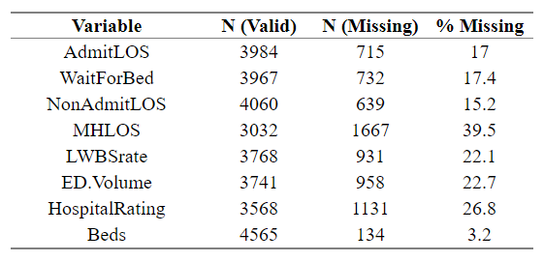  
TABLE 3: Rates of Missing Data

It is also important to note that data from U.S. territories have been removed. In addition to the 50 states plus D.C., Medicare also collects hospital performance metrics from U.S. territories including Puerto Rico, Virgin Islands, American Samoa, Guam, and Northern Mariana Islands. The issue with regard to this study is that the information that must legally be reported to Medicare is vastly different between the states and these territories. As a result, information on emergency department length of stay, boarding time, and LWBS rate from the territories is largely missing. The study population is therefore defined as Medicare-registered hospitals in the 50 U.S. states plus the District of Columbia. Also excluded are hospitals that did not report data on any of the five study outcome variables in 2018.

**Analysis**

**Exploratory Data Analysis**

*Study Outcome Variables*

Summaries of the five study outcome variables are presented here. Across the United States, the average patient who ultimately is admitted to the hospital spends four and a half hours in the emergency department. That stay includes, on average, a one hour and forty minute wait between the time of the physician decision to admit the patient to the hospital and the time they depart the emergency department for their inpatient bed. For dischanrged patients, the average emergency department length of stay is two hours and twenty minutes—approximately half that of admitted patients. For patients who arrive at the emergency department with a psychiatric or other mental health condition, the average length of stay balloons to over four hours. Finally, an average of 1.53% of all emergency department users leave the department without being seen. Summaries by state can be found in the Appendix.

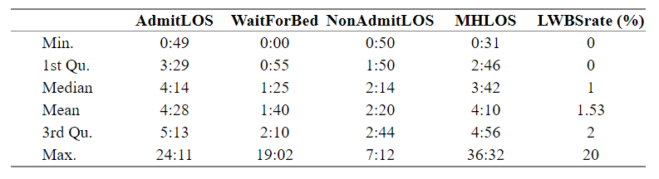  
 TABLE 4: Summary Statistics for Study Outcome Variables

Histograms of the repsonse variables are also presented, in order to show the shape and skewness of each, and give an idea of which models might be appropriate later on. All distributions of five variables are unimodal, approximately bell-shaped, and right-skewed. For *AdmitLOS* and *MHLOS*, the bulk of the hospital averages fall between two and six hours. For *NonAdmitLOS*, most discharged patients leave after an emergency department stay of one to four hours. With *WaitForBed*, most patients experience between zero and three hours of boarding time. Finally, *LWBSrate*, whose values in the original data were already rounded to the nearest 1%, typically clocks in at between zero three percent.

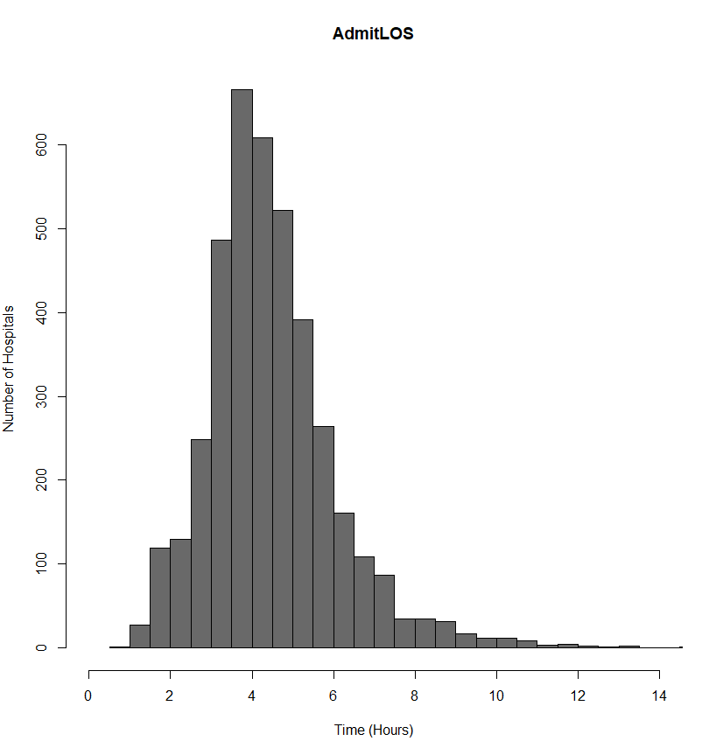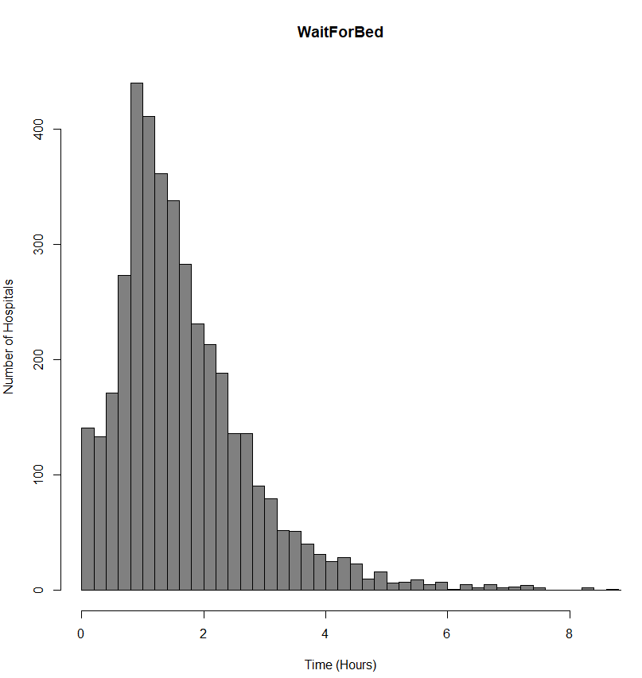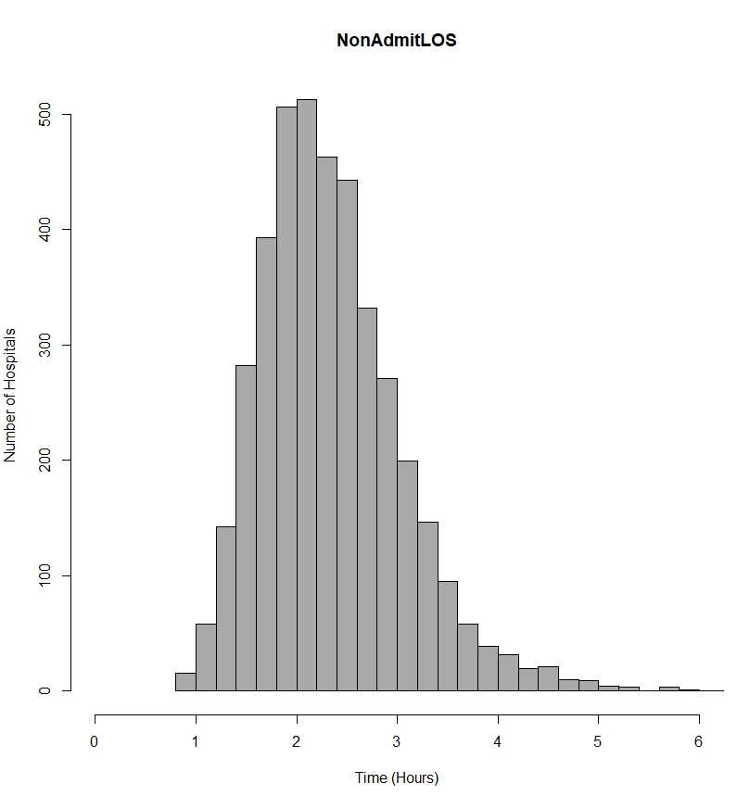

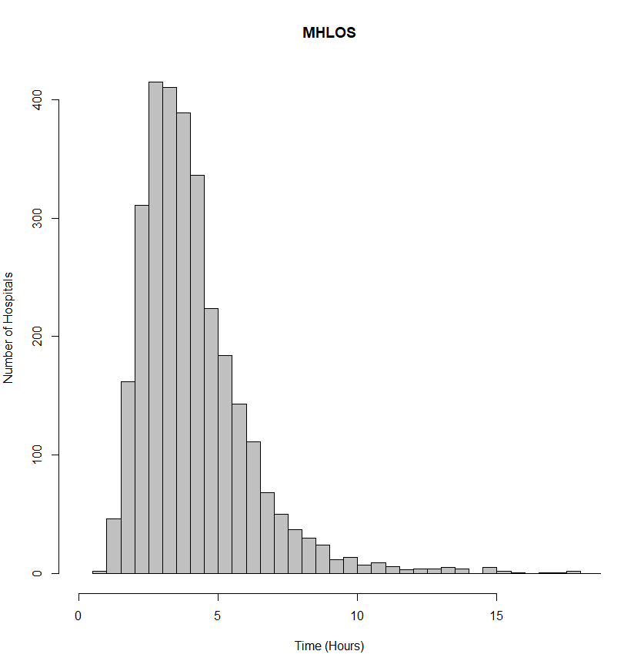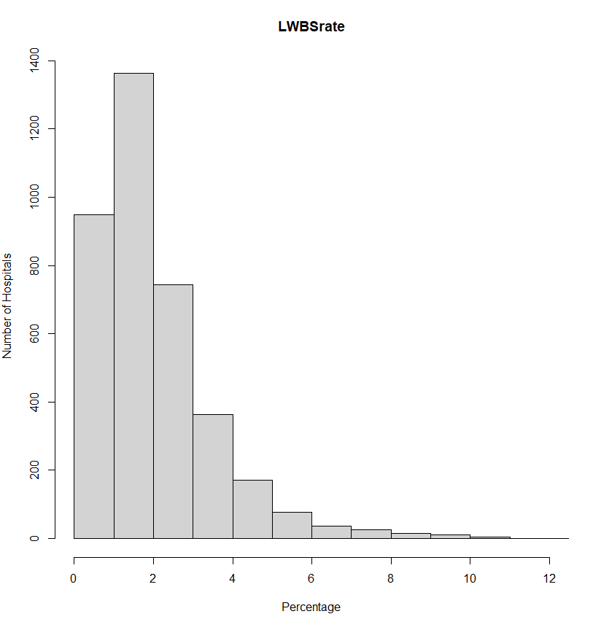  
FIGURE 1: Histograms of Study Outcome Variables

*Race/Ethnicity Variables*

The five race/ethnicity variables in the dataset are summarized here. While data pertaining to less prevalent races and ethnicities are available from the U.S. Census Bureau, because a vast majority of individuals living in the United States identifies with one or more of these groups, the decision is made to limit the scope of this study to these larger race/ethnicity categories.

As shown in Table 5, the typical (median) U.S. hospital serves a population that is 1.7% Asian or Pacific Islander, 5.5% Black or African-American, 6.4% Hispanic or Latino, 1.2% Native American, and 86.9% White. The notion of a “typical” hospital, however, may be misleading. While most U.S. hospitals serve high proportions of white patients, the large gaps between the “3rd Qu.” and “Max” values for each of the four non-white variables suggest that a small number of hospitals serve large proportions of non-white patients. This trend is confirmed by the histograms shown in Figure 2, where each of the non-white variables is heavily right skewed while proportion of white patients served is left skewed. This suggest that very few hospitals serve a majority of non-white patients.

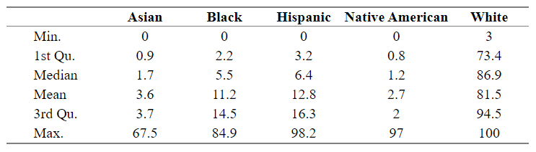TABLE 5: Summary of % of Patients Served at U.S. Hospitals Belonging to Each Race/Ethnicity

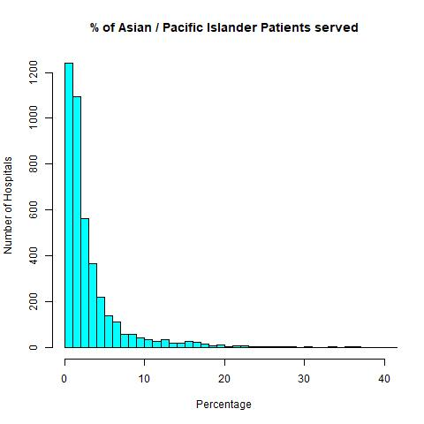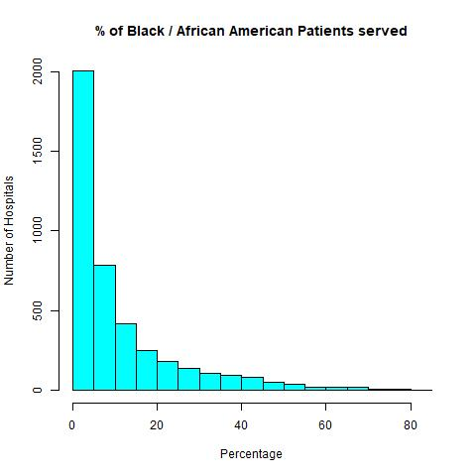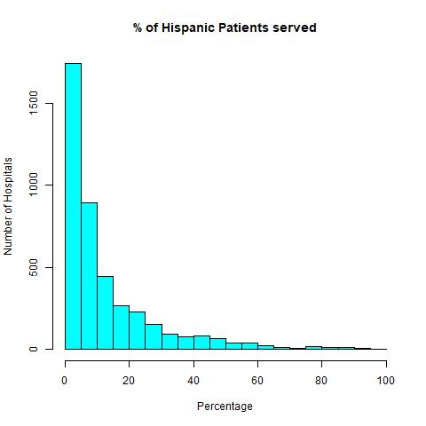

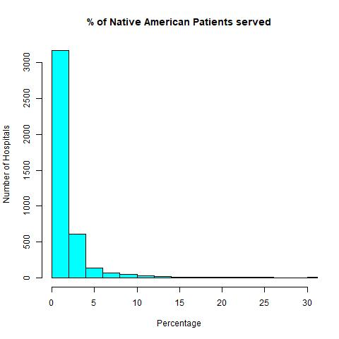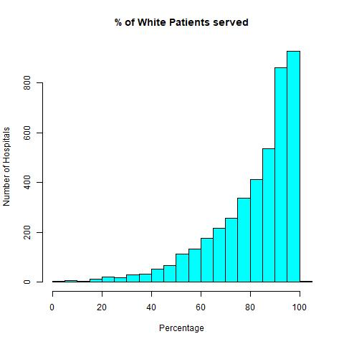  
FIGURE 2: Histograms of % of Patients Served at U.S. Hospitals Belonging to Each Race/Ethnicity

*Other Independent Variables*

The seven remaining independent variables are summarized below. It is here that it becomes apparent just how widely U.S. hospitals vary in terms of their size, location, and the population they serve. The summary begins with *Beds*, where the average number of Medicare-certified beds across U.S. hospitals is 187, but where the totals range wildly, from the 2-bed Johnson County Community Hospital in Mountain City, Tennessee to the 2891-bed Advent Health Hospital in Orlando, Florida. The histogram forms an exponential shape, with a heavy right skew. Following *Beds* is *Median Age*, the median age of patients served at U.S. hospitals, which appears to the normally distributed and has an average of 40.8 years old. *Rating* appears next, where U.S. hospitals average a score of 3.2 on Medicare’s 1 to 5 rating scale. While *Rating* can take on only five possible values, because its values are ordinal and form an approximately normal distribution in Figure 3, the decision is made to treat it as a numeric variable as opposed to a categorical one for the purposes of analysis. Next is *RuralScore*, where the “typical” (median) hospital serves a 42% rural population. However, as its histogram shows, the data are bimodal and are heavily skewed to the right and left, away from the average, meaning very few hospitals likely fit the “typical” profile. *Sex Ratio*, like *Median Age*, is approximately normally distributed, with the average hospital serving 99.1 men per 100 women. Finally, two of the variables, *Medicaid Expansion* and *ED Volume*, are categorical and so are excluded from Table 5, but can still be found in Figure 3. Their charts show that 62.7% of U.S. hospitals are located in a state that has expanded Medicaid while 37.3% are not, and that two-thirds of hospitals are categorized as having either Low or Medium emergency department volume.

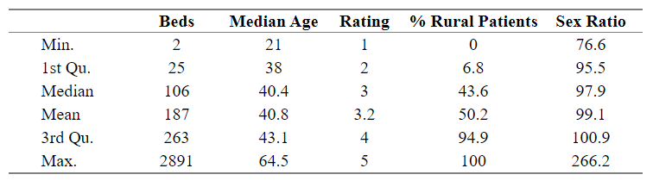  
TABLE 5: Summary Statistics for Beds per Hospital, Median Age of Patients Served, Hospital Overall Rating, % of Patients Served from a Rural Zip Code, and Male Patients Served per 100 Female Patients Served, Among U.S. Hospitals

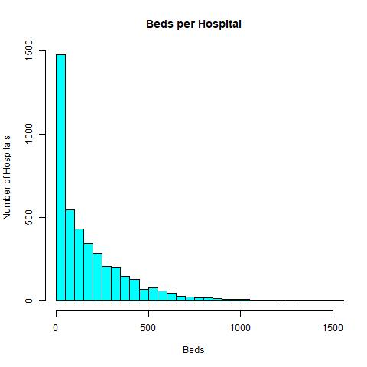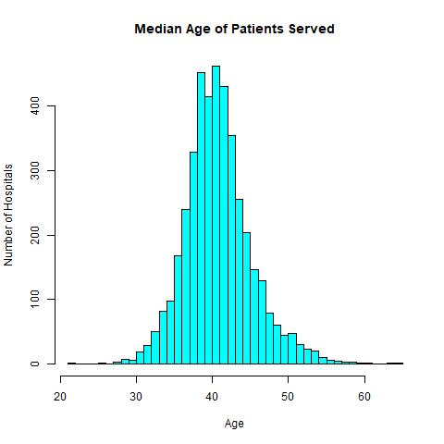

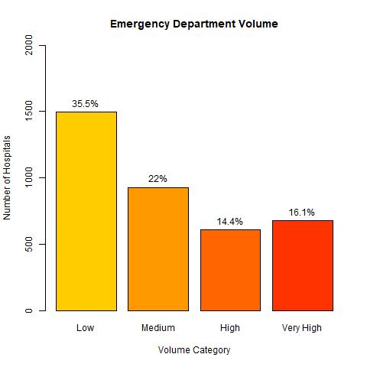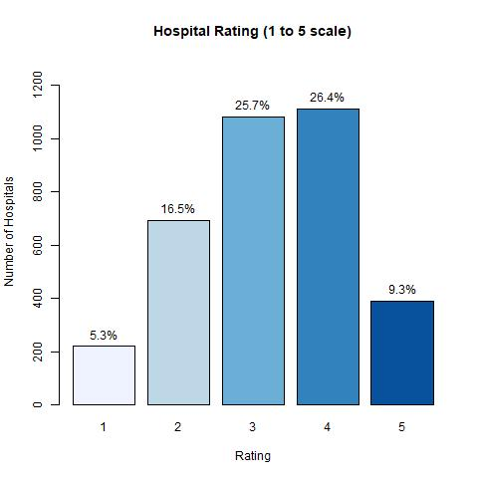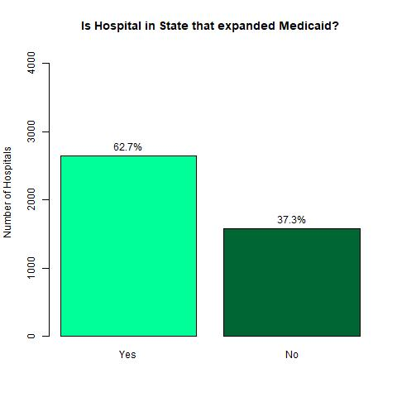

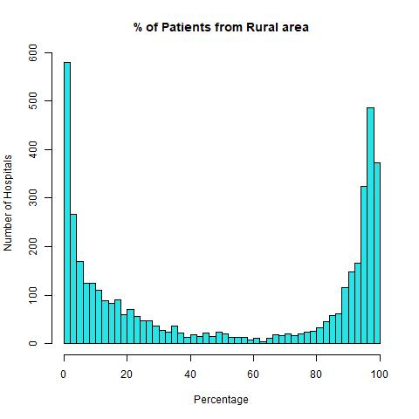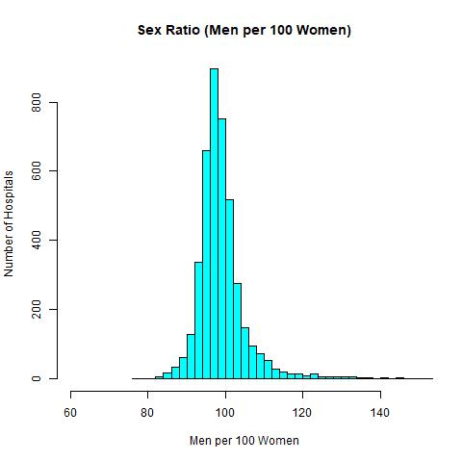  
  
  
FIGURE 3: Histograms for Beds per Hospital, Median Age of Patients Served, Emergency Department Volume, Hospital Overall Rating, Medicaid Expansion Status, % of Patients Served from a Rural Zip Code, and Male Patients Served per 100 Female Patients Served, Among U.S. Hospitals

**Assessment of Viable Models**

To build a series of successful predictive models for the five study outcome variables, the appropriate model for each must first be decided. Because these variables are naturally occurring integer counts of minutes, or proportions between zero and one, the most appropriate model for each is likely to come from the exponential family. Some common distributions from this family that can be modeled using Generalized Linear Models are Normal, Inverse Normal, Gamma, Poisson, Negative Binomial, and Beta. The goal of this section is to select the most appropriate model for each study outcome from among these distributions. Once the best models are selected, an optimal link function for each is also identified.

For *AdmitLOS*, *NonAdmitLOS*, and *MHLOS*, all non-missing values are positive integers, so each of the above distributions are considered, except Beta, which is only appropriate for modeling proportions. For *WaitForBed*, response values are also integers, but since zeroes are included among them, only models that accept zeroes as response values (Normal, Poisson, Negative Binomial) are considered. Lastly, for *LWBSrate*, where response values are proportions and include zero among them, only two distributions are appropriate: Normal and Beta. For Beta regression, which only accepts response values *between* zero and one, a transformation is employed to move values off of the extremes zero and one (Smithson & Verkuilen, 2006).

To test among these for the best performing, several dozen models are constructed, each using the four non-white race/ethnicity variables as predictors, and each featuring a different response distribution and link function. Models are assessed using Aikaike’s information criterion (AIC), a common method of choosing between predictive models with the same underlying data. Models are then chosen on the basis of their AIC values and the ease of model coefficient interpretation, which in the case of *AdmitLOS* and *MHLOS* led to the selection of a model that performs slightly worse according to AIC but whose results are much easier to interpret than the alternative. The chosen model for each study outcome variable is displayed below.

|  |  |
| --- | --- |
| **Response Variable** | **Model Selected** |
| *AdmitLOS* | Gamma GLM with Log Link |
| *WaitForBed* | Negative Binomial GLM with Log Link |
| *NonAdmitLOS* | Gamma GLM with Identity Link |
| *MHLOS* | Inverse Gaussian GLM with Log Link |
| *LWBSrate* | Beta GLM with Log Link |

TABLE 6: Optimal Models for Each Study Outcome Variable

**Model Structure**

The goal in constructing these models is to observe the influence of race/ethnicity on the five study outcome variables. For each study outcome, four models are presented that evaluate whether or not the influence of each race/ethnicity variable is statistically significant at the 95% level. The structure of the four models built for each response variable is outlined below. This structure will show the influence of the race/ethnicity variables both as their own set of predictors, and as predictors in the presence of other independent variables.

**Model 1:** Non-White Race/Ethnicity Variables Only (*Asian*, *Black*, *Hispanic*, *Native American*)

**Model 2:** Non-White Race/Ethnicity Variables + Other Demographics (*Median Age*, *Medicaid Expansion*, *Rural Score*, *Sex Ratio*)

**Model 3:** Non-White Race/Ethnicity Variables + Hospital Variables (*Beds*, *ED Volume*, *Rating*)

**Model 4:** Non-White Race/Ethnicity Variables + Other Demographics + Hospital Variables

**Model Diagnostics**

The final step before presenting model results is ensure that certain extreme observations are excluded from analysis, and that each model is an appropriate statistical fit to the underlying data. This task is accomplished in five parts: treatment and removal of outliers, a check for multicollinearity, evaluation of statistical independence of the response values, assessment of the mean-variance relationship, and confirmation of linearity on the link scale.

First, in order to have statistical confidence in the model results, it is important to ensure that models are not overly influenced by a small number of observations with abnormally large residuals. For that reason, the model residuals are inspected for outliers. Cook’s Distance plots are outputted for all twenty models, and all observations with a Cook’s Distance value of 0.5 or higher are removed. This resulted in a single observation being removed from three of the models. The *outlierTest* function (Fox & Weisberg, 2019) is also used to identify observations with the largest absolute studentized residuals and compute a Bonferroni p-value for each. Any observations with a p-value below .005 are removed.

Second, the models are examined for multicollinearity, a phenomenon where two or more independent variables in a model are so highly correlated that their contributions to the model cannot be meaningfully distinguished from one another. One way to measure for high correlation between independent variables is to compute their Variance Inflation Factor (VIF) values. Depending on the author, VIF values above 5 (Ringle, Wende & Becker, 2015) or above 10 (Hair et al., 1995) are to be considered concerning, and if that is the case, it is recommended that at least one of the independent variables be transformed or removed. Luckily, models in this study feature independent variables that are most uncorrelated with one another. The highest VIF value encountered across the twenty models is 2.63, for *ED Volume* as part of *AdmitLOS* Model 4.

The final three steps involve checking several statistical assumptions: independence, an appropriate mean-variance relationship, and linearity on the link scale. Graphical checks of each assumption for each response variable’s Model 4 can be found in the Appendix. To begin, while observations in the dataset were entered into the model in order of Medicare Facility ID, the graphs of residuals versus run order (Figure A-6) do not reveal any notable patterns that might suggest serial correlation. This provides us no evidence with which to reject the assumption of independence, so independence can reasonably be confirmed. Next, an appropriate mean-variance relationship between model predictions and model residuals is verified by examining each response variable’s residuals versus fitted values plots (Figure A-7) as well as quantile-quantile plots (Figure A-8). Though the effect of Medicare’s rounding of *LWBSrate* to the nearest 1% is clearly visible, the only other obvious pattern in the residuals vs. fitted plots is that variance in model residuals appears to be greater at higher model prediction values. This is typical of exponential models and is not concerning. In addition, Q-Q plots that assess how closely the observed distribution of residuals matches the underlying theoretical distribution (Gamma, Negative Binomial, Inverse Gaussian, or Beta, depending on the model) are shown. While residuals for *AdmitLOS*, *WaitForBed*, and *NonAdmitLOS* match their respective theoretical distributions quite closely, residuals for *MHLOS* and *LWBSrate* do not. While these mismatches do not violate the assumption of an appropriate mean-variance relationship for each model, models for *MHLOS* and *LWBSrate* may not perform as well as models for *AdmitLOS*, *WaitForBed*, and *NonAdmitLOS*. Finally, linearity on the link scale is assessed and confirmed. Though not displayed, partial residual plots showing the relationship between each response variable and each individual predictor are inspected (5 response variables, 10-11 independent variables each, 53 plots total). These graphs show primarily linear or curvilinear relationships between the response variables and each of their predictors. None appear to violate the assumption of linearity on the link scale.

**Results**

Final model results are presented here. To determine statistical significance, a 95% significance threshold (α = .05) is used. For models using a log link, exponentiated model coefficients are displayed. These exponentiated coefficients represent the multiplicative effect on the response variable for every one unit increase in the corresponding independent variable. For models using an identity link, coefficients instead represent the *additive* effect on the response variable for every one unit increase in an independent variable. It should be noted that each of the race/ethnicity variables, as well as *RuralScore*, are proportions between zero and one, so the coefficients for those variables represent the response effect as the proportion of patients served increases from 0% to 100%. Interpretations for these variables will be broken down into 10% increments. In addition, coefficients for each *ED Volume* and *Medicaid Expansion* level represent the change in the response variable, but only when compared to the baseline values, which are “Low” and “No,” respectively.

At the bottom of each regression table is an R2 score, used to evaluate overall model performance. This value represents the proportion of the variation in each response variable that can be explained by its relationship with the linear predictors for a given model. The twenty models presented range in performance from *LWBSrate* Model 1, which explains only 9.6% of the variation in *LWBSrate*, to *WaitForBed* Model 4, which explains a full 69.1% of the variation in *WaitForBed*.

*AdmitLOS*

Regression results for predictive models of *AdmitLOS,* the average (median) time from emergency department arrival to emergency department departure for patients admitted to the hospital as an inpatient, are shown on the following page. After controlling for a host of demographic and hospital-level covariates, the results of Model 4 show that among U.S. hospitals, a 10% increase in the proportion of Black or African-Americans patients served is associated with a 4.8% increase in *AdmitLOS* (p<.001). For proportion of Asian or Pacific Islander patients served, that increase is 4.1% (p<.001), while for proportion of Hispanic or Latino patients served the increase is 3.8% (p<.001). An increased *AdmitLOS* of 2% for every 10% increase in the proportion of Native American patients served was not statistically significant (p=.055).

Among the additional covariates, several interesting results stand out, most significantly that *AdmitLOS* is 13% higher in states that have expanded Medicaid under the Affordable Care Act of 2010 than in states that have not expanded (p<.001). Furthermore, *AdmitLOS* achieves an average of 6% lower at hospitals serving fully rural populations compared to hospitals serving fully urban populations (p<.001). Overall, the best performing model is Model 4, whose independent variables combine to explain 52.8% of the variability in *AdmitLOS*.

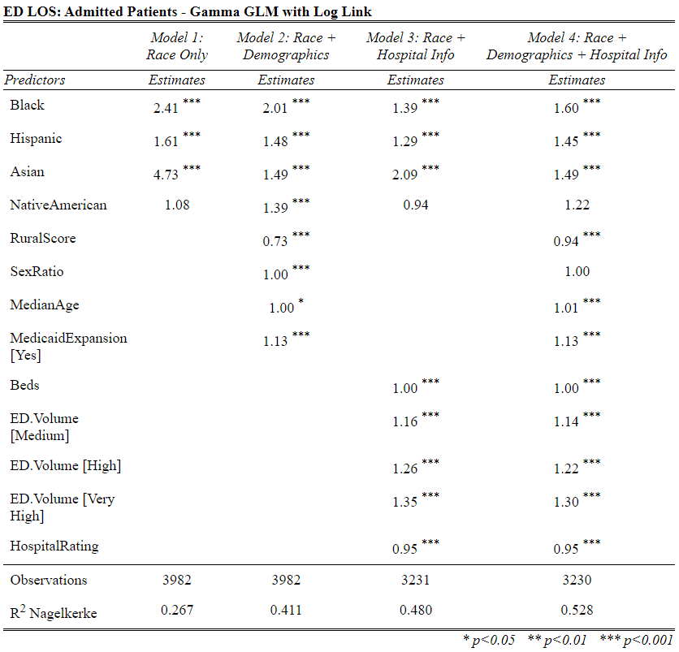

TABLE 6: Regression Results for *AdmitLOS*

*WaitForBed*

Results for the four predictive models of boarding time, the average time from admit decision to time of departure from the emergency department for patients admitted to the hospital as an inpatient, are shown below. After controlling for both hospital and other demographic variables, results show that for every 10% increase in the Asian or Pacific Islander population served, one can expect to observe an 8.2% increase in boarding time (p<.001). For Native American patients, Hispanic or Latino patients, and Black or African-American patients, those proportions are 7.9%, 6.1%, and 5.3%, respectively. Each of these associations are statistically significant (p<.001). In addition, boarding time averages 20% lower at hospitals serving all rural patients compared to hospitals serving all urban patients (p<.001), while boarding time in states that have expanded Medicaid is, on average, 21% higher than boarding time in states that have not (p<.001). Boarding time also appears to decrease 7% for every one star increase in hospital overall rating (p<.001).

It is here that the benefit of using both race/ethnicity and other relevant variables to model the response becomes apparent. While Model 1, featuring only race/ethnicity variables, accounts for only 28.2% of the variation in *WaitForBed*, Model 4, with seven predictors added, accounts for almost 70%. Coefficients for the race/ethnicity variables also vary drastically in the presence or absence of other predictor variables. For example, for the variable *Asian*, the proportion of Asian or Pacific Islander patients served, exp(β) = 23.79 in Model 1, which does not control for other, but only exp(β) = 2.19 in Model 4, which controls for seven independent variables. These results equate to far different conclusions: whereas Model 1 predicts a 37.2% increase in *WaitForBed* for every 10% increase in the proportion of Asian or Pacific Islander patients served, Model 4, the more robust model, predicts only an 8.1% change in *WaitForBed* for every 10% increase.

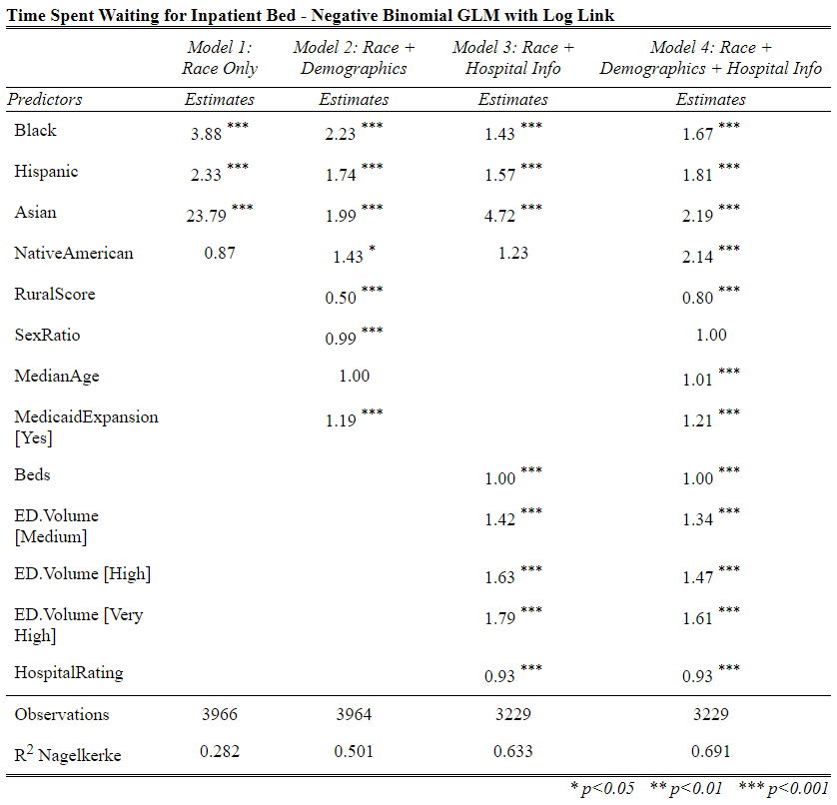  
  
TABLE 7: Regression Results for *WaitForBed*

*NonAdmitLOS*

Next, regression results for *NonAdmitLOS*, the average time from emergency department arrival to emergency department departure for discharged patients, are examined. Unlike with the other response variables, no link function used. The coefficients displayed below will therefore appear much higher than in other models because they represent the *additive* effect on *NonAdmitLOS* for every one unit increase in the corresponding independent variables, not the multiplicative effect.

Model 4 shows the effect of each race/ethnicity variable on *NonAdmitLOS*, after controlling for other relevant predictors. Here, a 10% increase in the proportion of Asian or Pacific Islander patients served is associated with an increased *NonAdmitLOS* of 2 minutes and 52 seconds (p<.05). That number for Hispanic or Latino, and Black or African-American patients is 2 minutes and 22 seconds (p<.001), and 2 minutes and 2 seconds (p<.001), respectively. Given that the national average for *NonAdmitLOS* is only 2 hours and 20 minutes, these average increases represent a significant gap in the quality of care administered to discharged patients at hospitals serving differing levels of non-white patients.

Among the other predictors from Model 4, a one year increase in the median age of patients served is associated with increased *NonAdmitLOS* of 47 seconds (p<.001), while a one-patient increase in the number of male patients served per 100 female patients is associated with a decreased *NonAdmitLOS* of 11 seconds (p<.01). These results suggest hospitals serving younger, more male populations likely have the shortest emergency department length of stay for discharged patients, with all other variables held equal.

Overall, the best performing model, Model 4, explains approximately 43% of the variation in emergency department length of stay for discharged patients.

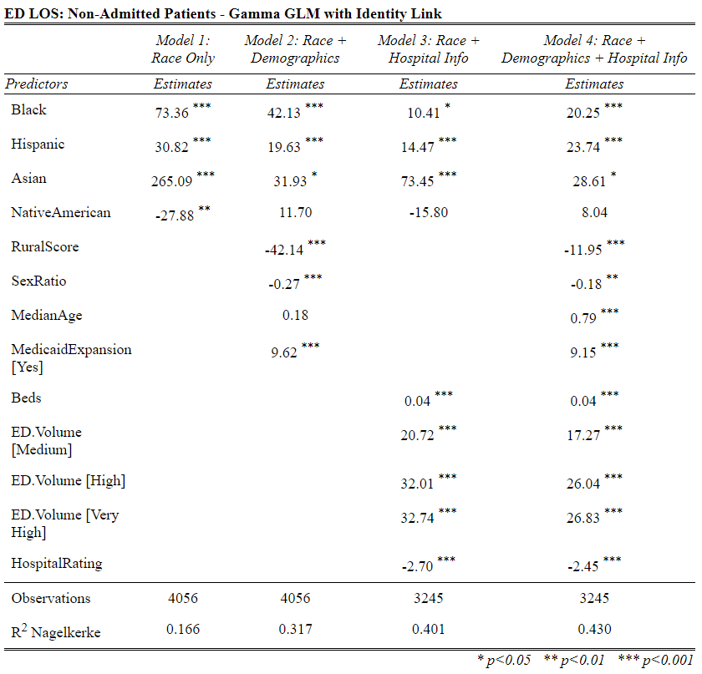  
  
TABLE 8: Regression Results for *NonAdmitLOS*

*MHLOS*

Regression results for *MHLOS*, the average time from emergency department arrival to emergency department departure for psychiatric or other mental health patients. While initial models suggest significant effects for other race/ethnicity variables, after controlling for all other independent variables (except *Beds* which is not significant in any *MHLOS* model), only the proportion of Black or African-American patients served is a significant predictor of emergency department length of stay for psychiatric or other mental health patients. As with *AdmitLOS*, a 10% increase in the proportion of Black or African-American patients served at a given hospital is associated with a 4.8% increase in *MHLOS*, with all other variables held equal(p<.001). Increases of 10% in the proportions of Asian or Pacific Islander, and Hispanic or Latino patients served are associated with 2.3% and 0.7% increases in *MHLOS*, respectively, but these associations are not statistically significant (p=.21; p=.27). Meanwhile, a 10% increase in the proportion of Native American patients served is associated with 2.1% decrease in *MHLOS*, though again this association is not significant (p=.30).

Among other the predictors, the coefficients for *ED Volume* stand out. Psychiatric and other mental health patients can expect a 40% longer stay in Very High volume emergency departments (p<.001), 29% longer in High volume emergency departments (p<.001), and 16% longer in Medium volume emergency departments (p<.001), than in Low volume emergency departments. Such patients can also expect an 11% shorter stay at hospitals serving fully rural populations compared to hospitals serving fully urban populations (p<.001), and an 8% longer stay at hospitals in states that have expanded Medicaid compared to states that have not expanded (p<.001).

Despite these significant associations, the models were based on fewer observations than models for *AdmitLOS*, *WaitForBed* and *NonAdmitLOS*, and did not perform as well. Model 4, the highest scoring model, explains only 23.4% of the variability inemergency department length of stay for psychiatric or other mental health patients.

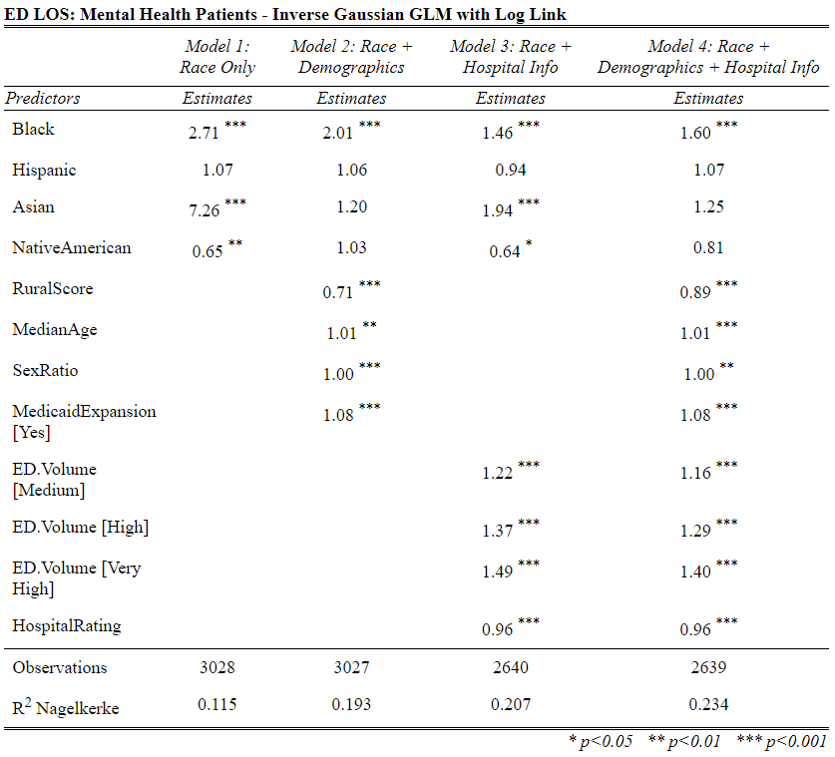TABLE 9: Regression Results for *MHLOS*

*LWBSrate*

Lastly, regression results for *LWBSrate*, the proportion of patients who leave the emergency department without being seen, are inspected. This is the rate of patients who arrive at the emergency department with a condition, register with front desk staff, are asked to wait, but ultimately leave the emergency department before being seen by a physician. Here, for every 10% increase in the proportion of Native Americans served at a given hospital, *LWBSrate* is predicted to rise by a full 27.1% (p<.001). For every 10% increase in the proportion of Black or African-American patients, a 13.5% increase is predicted (p<.001). Finally, for every 10% increase in the proportion of Hispanic or Latino patients served, *LWBSrate* is predicted to rise by 2.7% (p<.05). A predicted 4.7% decrease in *LWBSrate* for every 10% increase in the proportion of Asian or Pacific Islander patients served was not significant (p=.11).

Among the other independent variables, like with *MHLOS*, the independent variable *Beds*, which indicates the number of Medicare-certified beds per hospital, is not significant in any of the four *LWBSrate* models. In addition, there seems to be a strong relationship between *LWBSrate* and hospital overall rating—a one star increase in rating is associated with a 9% drop in *LWBSrate* (p<.001). Finally, a one-patient increase in the number of male patients served per 100 female patients is associated with a 1% drop in *LWBSrate* (p<.001), suggesting that hospitals serving higher proportions of women may have higher LWBS rates.

Overall, however, these models are generally poor performers, so the validity of the above conclusions should be considered suspect. The best model, Model 4, explains 12% of the variation in *LWBSrate* among hospitals in the final dataset.

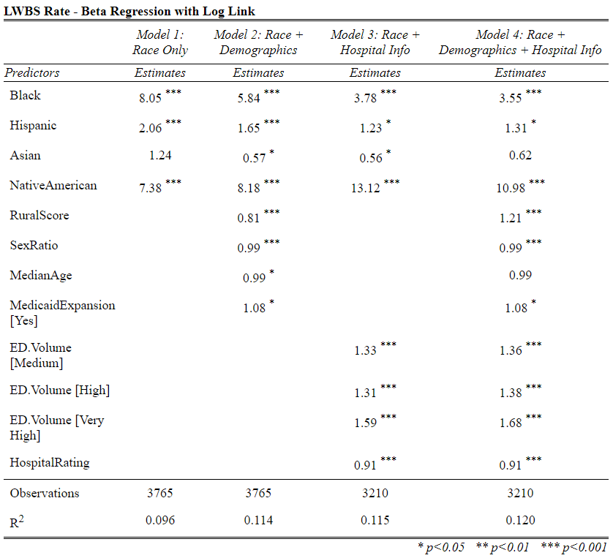  
  
TABLE 10: Regression Results for *LWBSrate* (*Beds* not significant)

**Discussion**

The overall results suggest that in 2018, when it came to emergency department length of stay, emergency department boarding time, and rate of patients leaving the emergency department without being seen, hospitals that served high rates of non-white patients generally performed worse than hospitals that served low rates of non-white patients. This conclusion was drawn from a set of statistical models that varied widely in their ability to predict the five study outcome variables. R2, the proportion of variability in a given study outcome variable that can be explained by its relationship with that model’s independent variables, was used to measure model performance. For each of the five study outcome variables, Model 4, the model controlling for the greatest number of independent variables, consistently outperformed Models 1, 2 and 3, which controlled for fewer variables. Among the Model 4s, *WaitForBed* performed best with an R2 of 0.691, followed by *AdmitLOS* with R2 = 0.528, *NonAdmitLOS* with R2 = 0.43, *MHLOS* with R2 = 0.234, and *LWBSrate* with R2 = 0.12.

These models reveal some disturbing patterns in emergency department performance. Most notably, the independent variable “proportion of Black or African-American patients served” was a statistically significant predictor in all twenty models. Emergency departments at hospitals serving high rates of Black or African-American patients have longer lengths of stay, longer boarding times, and higher rates of patients leaving the emergency department without being seen than other emergency departments. The results persisted despite attempts to control for as many as seven other independent variables. Perhaps the most concerning of these outcomes is that proportion of Black or African-American patients served is the only race/ethnicity variable significantly associated with emergency department length of stay for psychiatric or other mental health patients. To put this disparity in perspective, with all other independent variables held at national averages, a patient with a psychiatric or other mental health condition who arrives at the emergency department of hospital serving roughly 50% Black or African-American patients can expect a 20% longer stay (259 vs. 215 minutes) in the emergency department than they would at a hospital serving only 10% Black or African-American patients. This comes despite research suggesting that "Black people endure more intense and frequent mental and behavioral health issues than their counterparts, at least in part related to poverty and exposure to racism and discrimination, both of which disproportionally affect minorities" (Noonan, Velasco-Mondragon & Wagner, 2016). These conclusions suggest a pressing need for culturally specific investments in the mental health of Black patients, as well as increased investment in hospitals serving high rates of Black patients, and increased awareness of mental health care disparities that disproportionately impact Black people.

The results also suggest patients who use the emergency department at hospitals serving high rates of Hispanic or Latino patients are more likely to encounter a poorly performing emergency department than patients at hospitals serving low rates of Hispanic or Latino patients. Proportion of Hispanic or Latino patients served was a significant predictor of higher levels of all study outcome variables, except emergency department length of stay for psychiatric or other mental health patients. This comes despite that fact that Hispanics/Latinos are the largest minority group in the United States, accounting for nearly one-fifth of population (United States Census Bureau, 2019). Compared to patients in the emergency department of a hospital serving only 10% Hispanic or Latino patients, patients in the emergency department of a hospital serving 50% Hispanic or Latino patients experience 16% longer lengths of stay for admitted patients (288 minutes vs 248 minutes), 7% longer lengths of stay for discharged patients (142 minutes vs 133 minutes), 27% longer boarding times (104 vs. 82 minutes), and an 11% higher rate of patients leaving the emergency department without being seen (1.36% vs. 1.22%). These results suggest, at the very least, the need for increased investment in hospitals serving Hispanics and Latinos, and the need for more Spanish-speaking health care professionals.

In addition, proportion of Asian or Pacific Islander patients served is significant predictor of three or the five study outcome variables: *AdmitLOS*, *WaitForBed*, and *NonAdmitLOS*. Patients in the emergency department of a hospital serving 50% Asian or Pacific Islander patients are predicted to experience a 17% longer length of stay for admitted patients (301 minutes vs 257 minutes), 8% longer length of stay for discharged patients (146 minutes vs 135 minutes), and a 37% longer boarding time (120 vs. 88 minutes), than patients in the emergency department of a hospital serving only 10% Asian or Pacific Islander patients. This trend of lower emergency department performance among hospitals serving higher rates of Asian or Pacific Islander patients is consistent with other system-wide issues in health care affecting Asian Americans. Despite being relatively well-represented in the health care profession, Asian Americans report significant language barriers when accessing health care (Luthra, 2014). There is also tendency for health care professionals to generalize about the background and values of Asian American patients despite high levels of economic and cultural diversity within the Asian American community (Collins et al., 2002). Such patients would benefit from increased provider awareness of the cultural differences between different Asian American subgroups, as well as more access to interpreters, when needed, to help them better communicate their needs to the provider.

Finally, while proportion of Native American patients served is not a significant predictor of emergency department length of stay, it is a significant predictor of boarding time, and is the most significant race/ethnicity predictor by far of rate of patients leaving the emergency department without being seen. Hospitals serving high rates of Native American patients are far more likely to see a patient leave the emergency department without being seen than other hospitals. The best performing model for *LWBSrate* predicts that hospitals serving 50% Native American patients can expect *2.6 times* more patients to walk out of the emergency department without being seen than a hospital serving 10% Native American patients can. To begin to reverse this trend, governments at all levels, and all other funders of health care should consider diverting additional resources to providers serving high proportions of Native American patients specifically to address the problem of walkouts. According to Patel (2017), some recommended strategies for reducing the number of patients who leave the emergency department without being seen are: building an emergency department team that understands the goals and initiatives from the start, more efficient provider scheduling, increased quality incentives for providers, regular discussion of performance statistics among staff, and strong leadership from medical directors. Depending on the provider, additional cultural sensitivity training for staff may also be warranted.

As with most studies of social science data, this study featured a number of limitations that may have had an impacted the model results. The most significant limitation was that the original data from Medicare were not as precise as they could have been. All three length of stay variables, as well as boarding time, were rounded to the nearest minute prior to publication. This means, for example, that the performances of two hospitals whose average boarding times differ by up to 59 seconds might not be meaningfully distinguishable when it comes to length of stay or boarding time. Models of *LWBSrate* also suffered from rounding error because the original data were similarly rounded by Medicare to the nearest 0.01. Furthermore, because Medicare only requires hospitals to report performance data if they reach a sufficient sample size for a given data point, smaller, more rural hospitals may be slightly underrepresented in the underlying data. This suggests a possible overrepresentation of large urban hospitals in the final dataset used for modeling.

* Recommendations for future studies

**References**

American College of Emergency Physicians (2018). *Definition of Boarded Patient.* Policy Statements. <https://www.acep.org/patient-care/policy-statements/definition-of-boarded-patient/>

Association of American Medical Colleges (2019). *Diversity in Medicine: Facts and Figures 2019*. Figure 18. Retrieved from <https://www.aamc.org/data-reports/workforce/interactive-data/figure-18-percentage-all-active-physicians-race/ethnicity-2018>

Aquino, et al. (2018). *descr: Descriptive Statistics*. R package version 1.1.4. <https://CRAN.R-project.org/package=descr>

Artiga, S., Orgera, K., & Damico, A. (2020). *Changes in Health Coverage by Race and Ethnicity since the ACA, 2010-2018*. <https://www.kff.org/disparities-policy/issue-brief/changes-in-health-coverage-by-race-and-ethnicity-since-the-aca-2010-2018/>

Braveman, P., & Barclay, C. (2009). Health Disparities Beginning in Childhood: A Life-Course Perspective. *Pediatrics, 124*(Supplement 3), S163–S175. <https://doi.org/10.1542/peds.2009-1100d>

Cambridge Dictionary (n.d.) Inpatient. In *Cambridge Academic Content Dictionary*. Retrieved from <https://dictionary.cambridge.org/us/dictionary/english/inpatient>

Carron, P.-N., Yersin, B., Trueb, L., Gonin, P., & Hugli, O. (2014). Missed Opportunities: Evolution of Patients Leaving without Being Seen or against Medical Advice during a Six-Year Period in a Swiss Tertiary Hospital Emergency Department. *BioMed Research International, 2014*(1–8). <https://doi.org/10.1155/2014/690368>

Cecil G. Sheps Center for Health Services Research. (2019). *U.S. Hospital List* [XLSX]. Available from <https://www.shepscenter.unc.edu/programs-projects/rural-health/data/>

Centers for Medicare & Medicaid Services. (2019). *Hospital Service Area File*. (May 2019 Update)[CSV]. Available from <https://www.cms.gov/Research-Statistics-Data-and-Systems/Statistics-Trends-and-Reports/Hospital-Service-Area-File>

Centers for Medicare & Medicaid Services. (2019-2020). *Hospital Compare*. (Oct 2019 & Jul 2020 Updates)[CSV]. Available from <https://data.medicare.gov/data/archives/hospital-compare>

Collins, K. S., Hughes, D. L., Doty, M. M., Ives, B. L., Edwards, J. N., & Tenney, K. (2002). *Diverse communities, common concerns: assessing health care quality for minority Americans*. New York: Commonwealth Fund.

Cribari-Neto, F. & Zeileis, A. (2010). Beta Regression in R. *Journal of Statistical Software 34*(2), 1-24. <http://www.jstatsoft.org/v34/i02/>

Feng, C., Wang, H., Lu, N., Chen, T., He, H., Lu, Y., & Tu, X. M. (2014). Log-transformation and its implications for data analysis. *Shanghai Archives of Psychiatry, 26*(2), 105–109. <https://doi.org/10.3969/j.issn.1002-0829.2014.02.009>

Flores, G. (2010). Racial and Ethnic Disparities in the Health and Health Care of Children. *PEDIATRICS, 125*(4), e979–e1020. <https://doi.org/10.1542/peds.2010-0188>

Fox, J. & Weisberg, S. (2019). *car: An R Companion to Applied Regression, Third Edition*. Sage Publishing.

Garfield, R., Orgera, K. & Damico, A. (2020). *The Coverage Gap: Uninsured Poor Adults in States that Do Not Expand Medicaid*. Kaiser Family Foundation. <https://www.kff.org/medicaid/issue-brief/the-coverage-gap-uninsured-poor-adults-in-states-that-do-not-expand-medicaid/>

Georgetown University Health Policy Institute. (n.d.). *Rural and Urban Health*. <https://hpi.georgetown.edu/rural/>

Goyal, M. K., Kuppermann, N., Cleary, S. D., Teach, S. J., & Chamberlain, J. M. (2015). Racial Disparities in Pain Management of Children with Appendicitis in Emergency Departments. *JAMA Pediatrics, 169*(11), 996. <https://doi.org/10.1001/jamapediatrics.2015.1915>

Hair, J. F. Jr., Anderson, R. E., Tatham, R. L. & Black, W. C. (1995). *Multivariate Data Analysis (3rd ed)*. New York: Macmillan.

Haywood, C., Jr., Tanabe, P., Naik, R., Beach, M. C., & Lanzkron, S. (2013). The impact of race and disease on sickle cell patient wait times in the emergency department*. The American Journal of Emergency Medicine, 31*(4), 651–656. <https://doi.org/10.1016/j.ajem.2012.11.005>

Himmelstein, D. U., & Woolhandler, S. (2016). The Current and Projected Taxpayer Shares of US Health Costs*. American Journal of Public Health, 106*(3), 449–452. <https://doi.org/10.2105/ajph.2015.302997>

Hsia, R. Y., Asch, S. M., Weiss, R. E., Zingmond, D., Liang, L.-J., Han, W., McCreath, H., & Sun, B. C. (2011). Hospital Determinants of Emergency Department Left Without Being Seen Rates. *Annals of Emergency Medicine, 58*(1), 24-32.e3. <https://doi.org/10.1016/j.annemergmed.2011.01.009>

Jacobs, E. A., Rolle, I., Ferrans, C. E., Whitaker, E. E., & Warnecke, R. B. (2006). Understanding African Americans’ views of the trustworthiness of physicians. *Journal of General Internal Medicine, 21*(6), 642–647. <https://doi.org/10.1111/j.1525-1497.2006.00485.x>

Kaiser Family Foundation. (2020). *Status of State Action on the Medicaid Expansion Decision*. <https://www.kff.org/health-reform/state-indicator/state-activity-around-expanding-medicaid-under-the-affordable-care-act/>

Lee, H. H., Lewis, C. W., & McKinney, C. M. (2016). Disparities in Emergency Department Pain Treatment for Toothache. *JDR Clinical & Translational Research, 1*(3), 226–233. <https://doi.org/10.1177/2380084416655745>

Luthra, S. (2014). *Even With Insurance, Language Barriers Could Undermine Asian Americans’ Access To Care*. Kaiser Health News. https://khn.org/news/even-with-insurance-language-barriers-could-undermine-asian-americans-access-to-care/

Lüdecke, D. (2020). *sjPlot: Data Visualization for Statistics in Social Science*. R package version 2.8.4. <https://CRAN.R-project.org/package=sjPlot>

Medicaid (2020). *About Medicaid.* Center for Medicare and Medicaid Services. <https://www.medicaid.gov/medicaid/index.html>

Medicare (n.d.) *What’s Medicare?* Medicare.gov, The Official U.S. Government Site for Medicare. <https://www.medicare.gov/what-medicare-covers/your-medicare-coverage-choices/whats-medicare>

Merriam-Webster. (n.d.). Zip-code. In *Merriam-Webster.com dictionary*. Retrieved from https://www.merriam-webster.com/dictionary/zip-code

National Center for Health Statistics. (2018). *National Ambulatory Medical Care Survey 2018 Patient Record Card*. <https://www.cdc.gov/nchs/data/ahcd/2018_NAMCS_Patient_Record_Sample_Card.pdf>

National Rural Health Association (n.d.) *About Rural Health Care*. Rural Information Health Hub. <https://www.ruralhealthweb.org/about-nrha/about-rural-health-care>

Nelder, J. A., & Wedderburn, R. W. M. (1972). Generalized Linear Models. *Journal of the Royal Statistical Society. Series A (General), 135*(3), 370. <https://doi.org/10.2307/2344614>

Neuwirth, E. (2014). *RColorBrewer: ColorBrewer Palettes*. R package version 1.1-2. <https://CRAN.R-project.org/package=RColorBrewer>

Noonan, A. S., Velasco-Mondragon, H. E., & Wagner, F. A. (2016). Improving the health of African Americans in the USA: an overdue opportunity for social justice. *Public Health Reviews, 37*(1). https://doi.org/10.1186/s40985-016-0025-4

Okunseri, C., Okunseri, E., Chilmaza, C. A., Harunani, S., Xiang, Q., & Szabo, A. (2013). Racial and ethnic variations in waiting times for emergency department visits related to nontraumatic dental conditions in the United States. *Journal of the American Dental Association (1939), 144(*7), 828–836. <https://doi.org/10.14219/jada.archive.2013.0195>

Pines, J. M., Russell Localio, A., & Hollander, J. E. (2009). Racial Disparities in Emergency Department Length of Stay for Admitted Patients in the United States. *Academic Emergency Medicine, 16*(5), 403–410. <https://doi.org/10.1111/j.1553-2712.2009.00381.x>

Plunkett, P. K., Byrne, D. G., Breslin, T., Bennett, K., & Silke, B. (2011). Increasing wait times predict increasing mortality for emergency medical admissions. *European Journal of Emergency Medicine, 18*(4), 192–196. <https://doi.org/10.1097/mej.0b013e328344917e>

R Core Team (2017). *R: A language and environment for statistical computing*. R Foundation for Statistical Computing. <https://www.R-project.org/>

Ramakrishnan, K. & Ahmad, F. Z. (2014). *State of Asian Americans and Pacific Islanders Series: A Multifaceted Portrait of a Growing Population*. Center for American Progress. https://cdn.americanprogress.org/wp-content/uploads/2014/04/AAPIReport-comp.pdf

Richardson, D. B. (2006). Increase in patient mortality at 10 days associated with emergency department overcrowding. *Medical Journal of Australia, 184*(5), 213–216. <https://doi.org/10.5694/j.1326-5377.2006.tb00204.x>

Ringle, Christian M., Wende, Sven, & Becker, Jan-Michael. (2015). *SmartPLS 3*. Bönningstedt: SmartPLS. Retrieved from http://www.smartpls.com

RStudio Team (2020). RStudio: Integrated Development for R. RStudio, PBC, Boston, MA. Available from http://www.rstudio.com/

Saha, S., Taggart, S. H., Komaromy, M., & Bindman, A. B. (2000). Do Patients Choose Physicians Of Their Own Race? *Health Affairs, 19*(4), 76–83. <https://doi.org/10.1377/hlthaff.19.4.76>

Shaikh, S., Jerrard, D., Witting, M., Winters, M., & Brodeur, M. (2012). How Long Are Patients Willing to Wait in the Emergency Department Before Leaving Without Being Seen. *Western Journal of Emergency Medicine, 13*(6), 463–467. <https://doi.org/10.5811/westjem.2012.3.6895>

Shiel, W. C. (2018). *Medical Definition of Emergency Department*. Medicine Net. <https://www.medicinenet.com/script/main/art.asp?articlekey=12156>

Singh, G. K., & Siahpush, M. (2014). Widening Rural–Urban Disparities in Life Expectancy, U.S., 1969–2009. *American Journal of Preventive Medicine, 46*(2), e19–e29. <https://doi.org/10.1016/j.amepre.2013.10.017>

Smithson, M., & Verkuilen, J. (2006). A better lemon squeezer? Maximum-likelihood regression with beta-distributed dependent variables. *Psychological Methods, 11*(1), 54–71. https://doi.org/10.1037/1082-989x.11.1.54

Tamayo-Sarver, J. H., Hinze, S. W., Cydulka, R. K., & Baker, D. W. (2003). Racial and Ethnic Disparities in Emergency Department Analgesic Prescription. *American Journal of Public Health, 93*(12), 2067–2073. <https://doi.org/10.2105/ajph.93.12.2067>

United States Census Bureau (2018). *American Community Survey*. (2018 Version)[CSV]. Available from <https://data.census.gov/cedsci/table?g=0100000US.860000&tid=ACSDP5Y2018.DP05>

United States Census Bureau (2019). *Quick Facts*. Retrieved from <https://www.census.gov/quickfacts/fact/table/US/IPE120218>

United States Office of Rural Health Policy. (2019). *FORHP Eligible ZIP Codes* [XLS]. Available from <https://www.hrsa.gov/rural-health/about-us/definition/datafiles.html>

Valuates Reports (2019). *Healthcare Analytics Market Report*. 360i Research. <https://reports.valuates.com/market-reports/360I-Auto-0U39/global-healthcare-analytics-market>

Venables, W. N. & Ripley, B. D. (2002). *Modern Applied Statistics with S. Fourth Edition*. Springer Publishing.

Vermeulen, M. J., Stukel, T. A., Guttmann, A., Rowe, B. H., Zwarenstein, M., Golden, B., Nigam, A., Anderson, G., Bell, R. S., Schull, M. J., Afilalo, M., Anderson, G., Bell, R. S., Carew, D., Carter, M., Cooke, M., Golden, B., Guttmann, A., Nigam, A., … Zwarenstein, M. (2014). Evaluation of an Emergency Department Lean Process Improvement Program to Reduce Length of Stay. *Annals of Emergency Medicine, 64*(5), 427–438. <https://doi.org/10.1016/j.annemergmed.2014.06.007>

Wickham, H. & Bryan, J. (2019). *readxl: Read Excel Files*. R package version 1.3.1. <https://CRAN.R-project.org/package=readxl>

Wickham, et al. (2019). Welcome to the tidyverse. *Journal of Open Source Software, 4*(43), 1686. <https://doi.org/10.21105/joss.01686>

Willoughby, K. A., Chan, B. T. B., & Strenger, M. (2010). Achieving wait time reduction in the emergency department. *Leadership in Health Services, 23*(4), 304–319. <https://doi.org/10.1108/17511871011079010>

Wilson, S., Dev, S., Mahan, M., Malhotra, M., & Miller, J. (2016). Identifying disparity in emergency department length of stay and admission likelihood. *World Journal of Emergency Medicine, 7*(2), 111–116. <https://doi.org/10.5847/wjem.j.1920-8642.2016.02.005>

Xie, Y. (2015). *Dynamic Documents with R and knitr: 2nd Edition*. Chapman and Hall.

Zhang, X., Carabello, M., Hill, T., He, K., Friese, C. R., & Mahajan, P. (2019). Racial and Ethnic Disparities in Emergency Department Care and Health Outcomes Among Children in the United States. *Frontiers in Pediatrics, 7*. <https://doi.org/10.3389/fped.2019.00525>

**Appendix**

**TABLE A-1: Averages by State for Length of Stay, Wait Time, LWBS Rate and Hospital Rating**

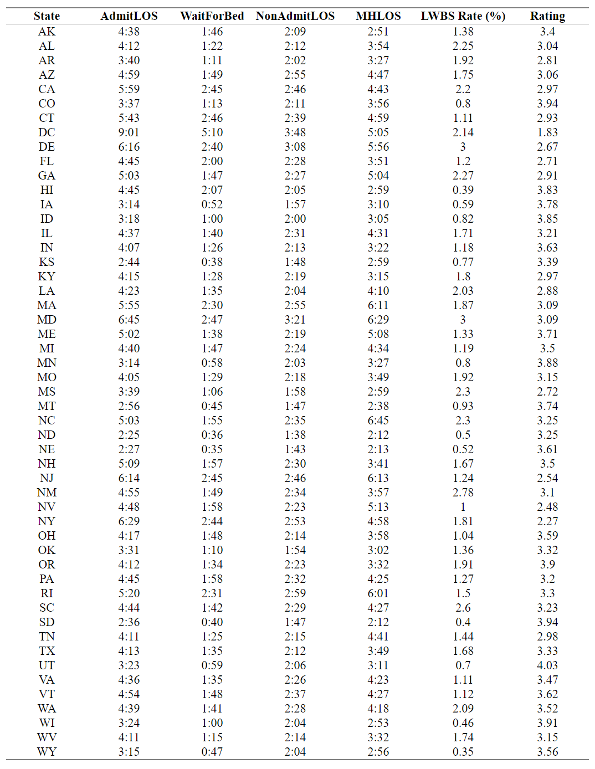

**TABLE A-2: Correlation Coefficients for all Pairwise Combinations of Continuous Variables**

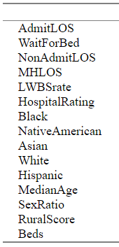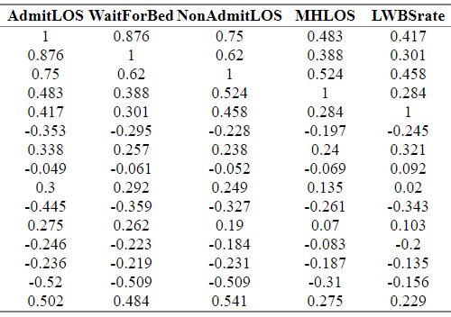

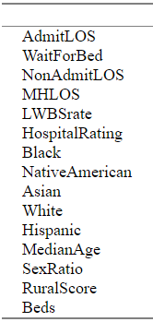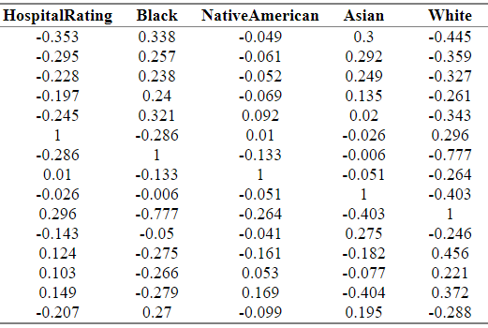

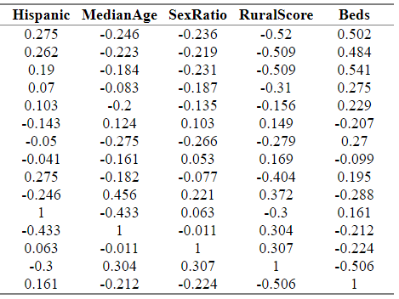

**FIGURES A-1 to A-5: Charts of Missing Data Rates by Race/Ethnicity and by Hospital Size/Location**

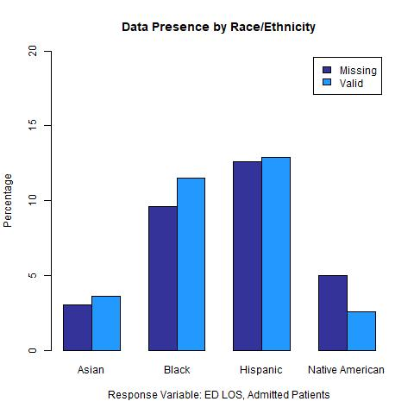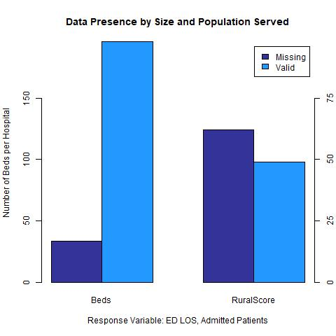

FIGURE A-1: Rates of Missing Data for *AdmitLOS*

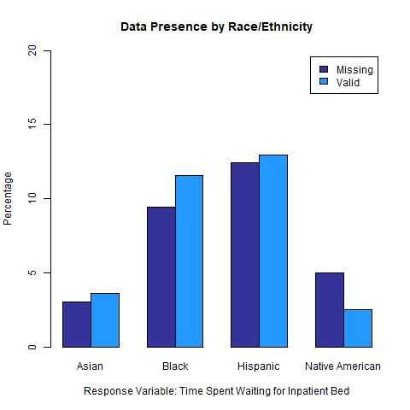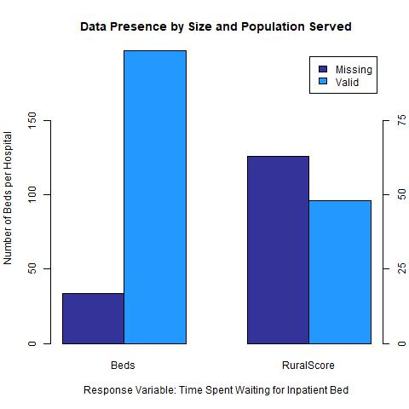

FIGURE A-2: Rates of Missing Data for *WaitForBed*

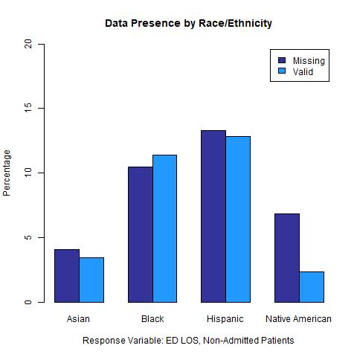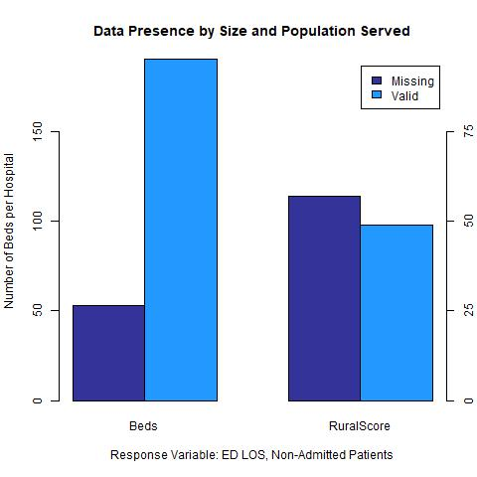

FIGURE A-3: Rates of Missing Data for *NonAdmitLOS*

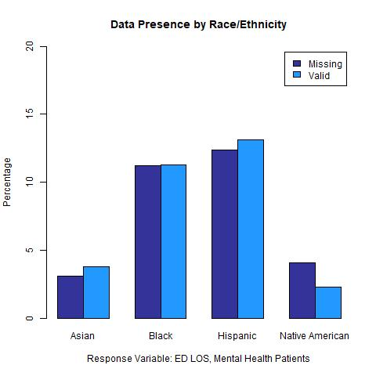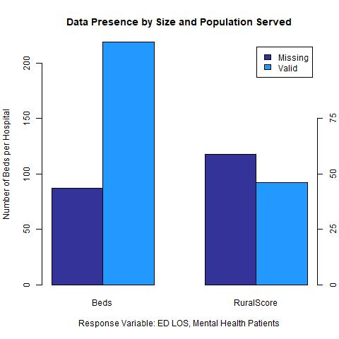

FIGURE A-4: Rates of Missing Data for *MHLOS*

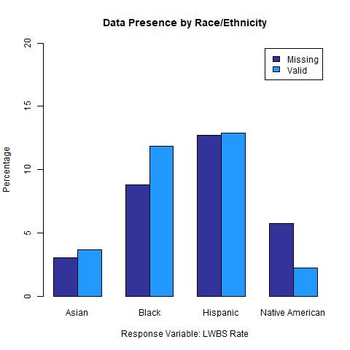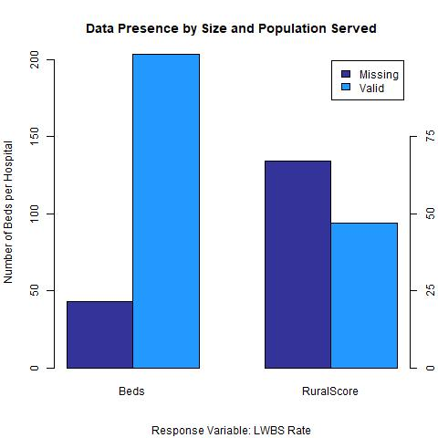

FIGURE A-5: Rates of Missing Data for *LWBSrate*

**FIGURES A-6 to A-8: Model Diagnostic Plots**

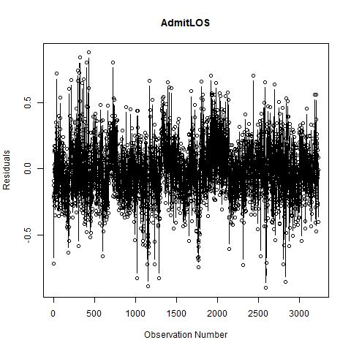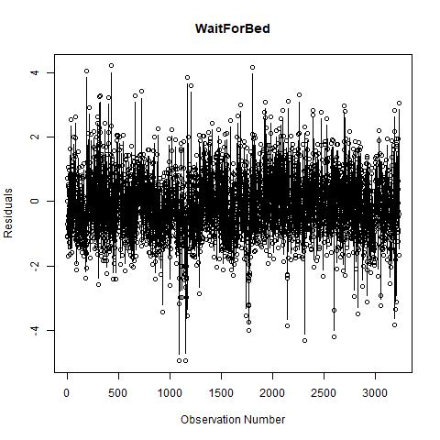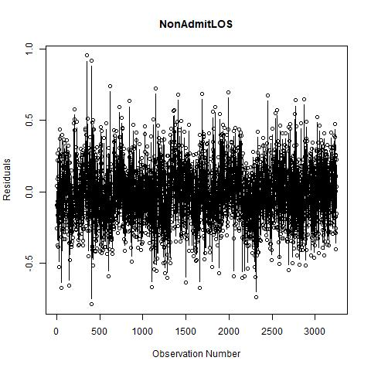

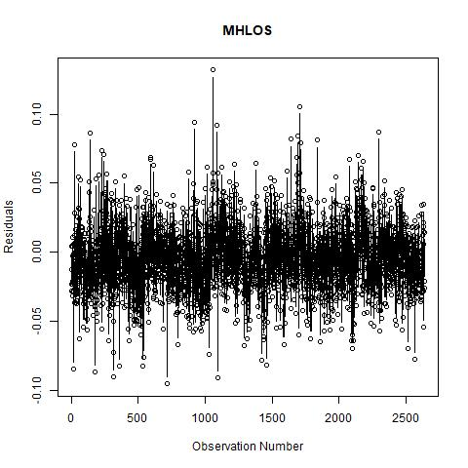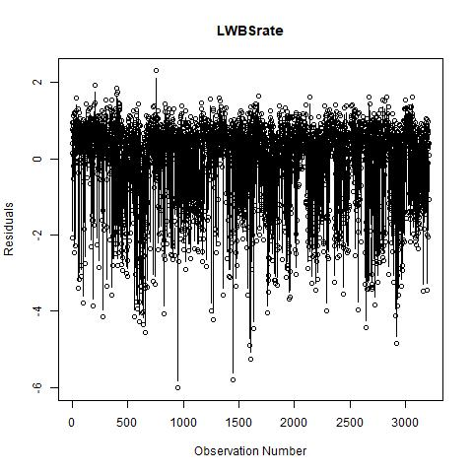

FIGURE A-6: Residuals vs Run Order Plots

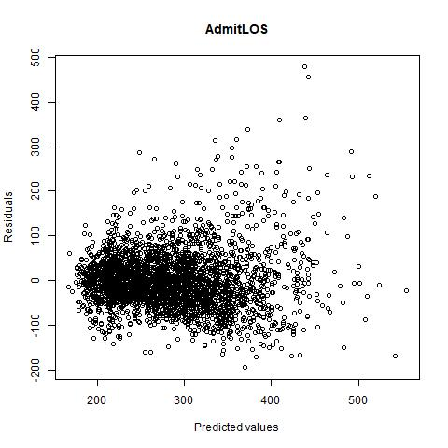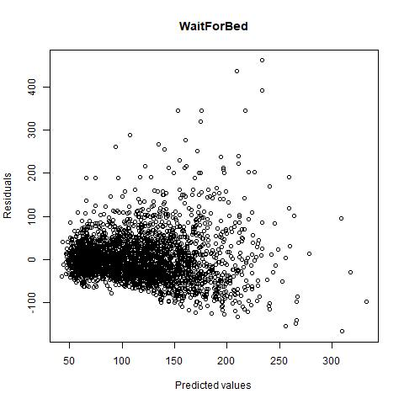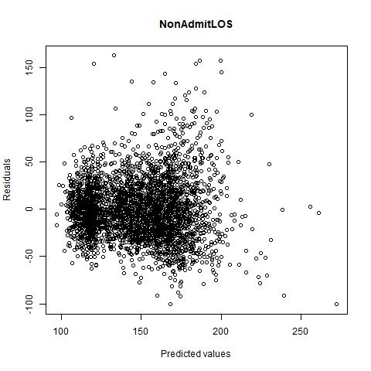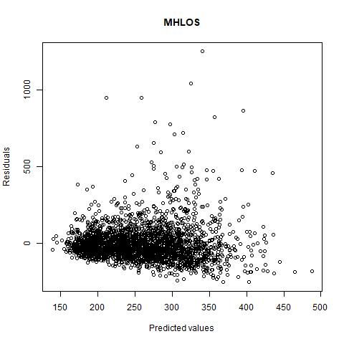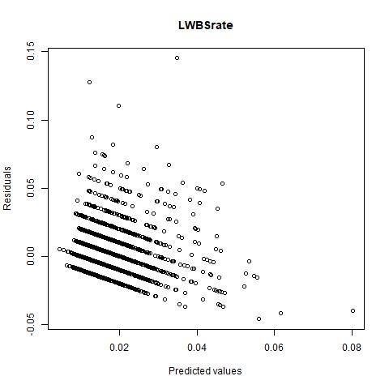

FIGURE A-7: Raw Residuals vs Fitted Values Plots

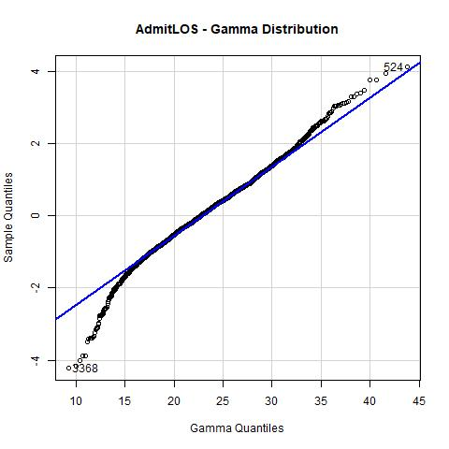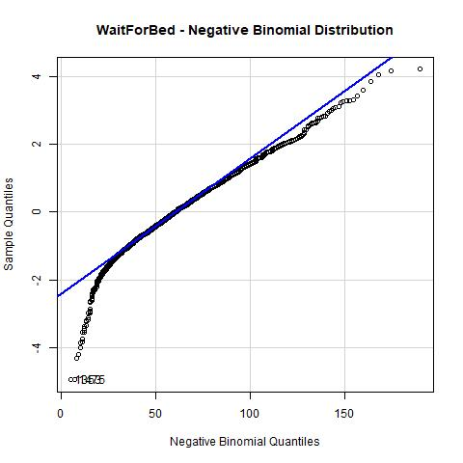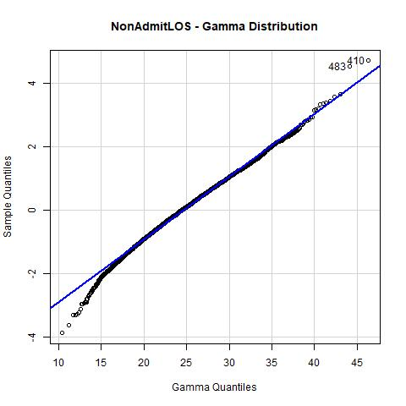

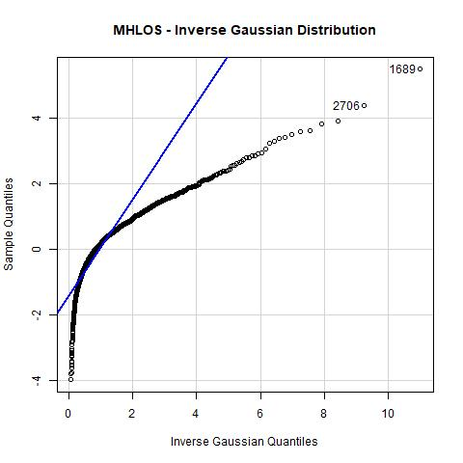 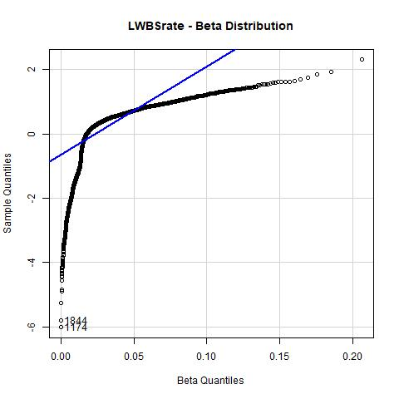

FIGURE A-8: Quantile-Quantile (Q-Q) Plots